5/2/2018
Marissa Adawag
Water Environment Federation
MA Online and Rebate Reports

Table of Contents

Overview 3
Common Definitions: 3
Reports: 3
MA Negative Change Report 3
MA Email Report 4
MA Demographic Report 4
MA Dashboard 4
MA Committee Roster 4
MA Member Roster 4
MA Address Change Report 4
MA Members of Utility Partnership Program (UPP) 5
MA Expired Members Report 5
MA Negative Change Report with Expiration Date 5
MA Members License Information 5
MA Membership Data Dump & New MA Membership Data Dump 5
MA New Members Report 5
Rebate Report 5
Accessing MA Online and MA Rebate Reports: 7
Access Instructions 7
Generating and Saving Reports 10
Browser Configurations 12
Firefox 13
Chrome 13
Internet Explorer 11 or Bing 14
MA Rebate Reports 18
Accessing Membership Directory………………………………………………………………………………………………………………………………………………………………………… 21
Access Instructions…………………………………………………………………………………………………………………………………………………………………………………………22

Overview

The MA Online reports are a series of reports that were designed by the Member Associations (MAs). These reports extrapolate MA membership data from WEF. There are several reports and are downloadable in Excel. The MA Rebate report is a report that is generated with month end close and contains the member rebate payments that are in your monthly electronic money transfer.

Common Definitions:

Current Member – Is a member as of the date the reports are run. Each WEF member usually has a 12 month term and a 3 additional month grace period.
Membership Revenue Year to Date (YTD) – revenue is based on a calendar year of January – December
Membership Revenue Month to Date (MTD) – revenue is based on the current month the report is run
Expired Members in Current Month – Members who have expired in the current month. These are members who are beyond their 12 month membership term and their 3 month grace term so in the current month, they are no longer considered members
Grace Members in Current Month – Members who are in a grace status in the current month. They are in their delinquent/lapsed period
New Members – Members who are in their first year of membership. This is based on the original join date of the member
Expired Members – Members who have expired within the last 3 months of the current month. These members are no longer in their grace period.

Reports:
NOTE: Each MA is guaranteed one license holder and may request an additional license holder. All reports are exportable into EXCEL except where noted

WEF Committee & Roster
The purpose of this report is to provide the MAs with a listing of their members and which WEF committees they serve and in what position. It also provides a list of those officers for your MA that are WEF members

Member Roster
The purpose of this report is to provide the MAs with an appealing roster of their members. It is a short list than those in the contact data transfer report and contains mailing, email, phone and limited membership information

Address Change Report
The purpose of this report is to retrieve address change information associated to the members of the MA. You are able to filter on last modified date for the mailing address.

UPP Members Report
The purpose of this report is to provide the MA a listing of members that are now part of the Utility Partnership program. You are able to sort on any of the columns

Expired Members Report
The purpose of this report is to provide MA a listing of members that lapsed/expired membership. This report includes all MA members who expired in the last year from the date the report is generated. The report contains contact information of the former member. Deceased members are excluded. You can export to Excel and sort/filter or you can filter on the expired date within the online report

Members License
The purpose of this report is to provide all the license information that WEF collects on members. There can be multiple licenses and multiple states per an individual member.

Contact Data Transfer Report and Company Data Transfer Report
The purpose of this report is to provide the MAs the ability to “push a button” and produce an excel spreadsheet of customer and order detail information on their members. Typically this file is uploaded into the MA’s database – or this file of data acts as the Membership Roster for that MA. This report excludes members with cancelled and deceased status. These report can’t be modified without the approval of the majority of the MAs who elect to vote on changes. If you run one MA Online report, it should be this one. There is an additional document that contains the file layout for this report

New Members Report
The purpose of this report is to provide the MA a listing of new members. This report has the last 12 months plus the current month of new members. You can change the filter or you can export the report and filter on it in Excel

All Contacts
This report was built by Fonteva as a report that feeds information into other reports. It does list all members with limited information and should not be used as a stand along report

Subscriptions by Type
This is the report that feeds the MA Home Page Dashboard. It lists the members by their membership type

MA Rebate by Date
The rebate report is generated with WEF’s month end close and contains the backup information for the rebate amounts that are sent to each MA. This report initial displays al rebates for the last 60 days. You can change the transaction line date filter to increase/decrease the period you need This report contains the
- Member ID
- Member first name
- Member last name
- Account/company
- Membership type/category
- Membership Start date
- Paid Through Date
- Date we received payment
- Credit – the amount we are remitting to you
- Debit – the amount that was cancelled or refunded to the member

Accessing MA Online and MA Rebate Reports:

Access Instructions
- Go to https://connect.wef.org/MA/s
- Enter your login information.

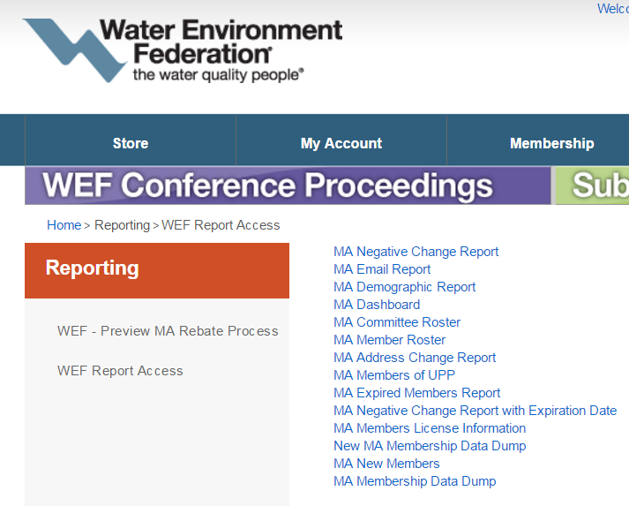

Generating and Saving Reports

- Double click on the report that you would like to run and enter any information that the report prompt requests. You will need to enter the MA Access code that you were emailed. If you don’t have your MA Access code, please contact Marissa Adawag – madawag@wef.org

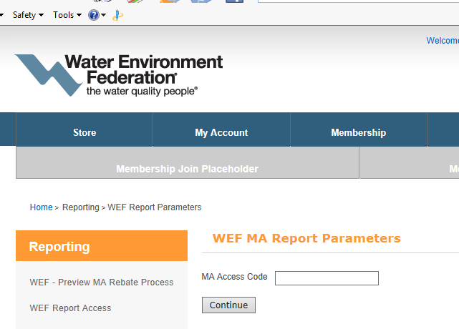

- After you run a report your screen displays the report output
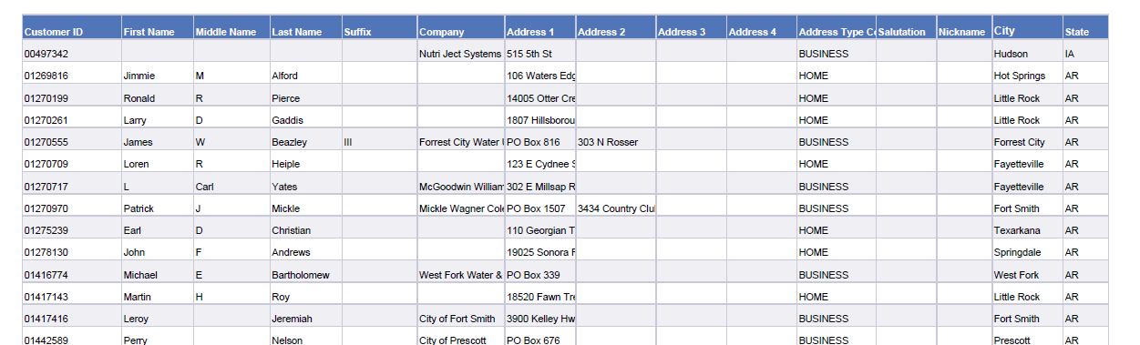

The reports default to PDF format, therefore, you will need to change the format in order to download them into EXCEL. We are unable to change the default as that is part of the reporting software. To save or change formats please follow these steps:

  - Click the down arrow next to Reading option (upper right corner) and select HTML
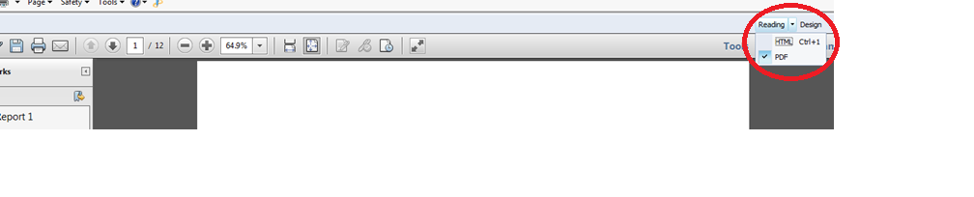

  - Click the down arrow 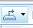 to display available formats that you can export the report into.
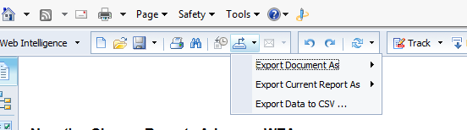

Browser Configurations
Different browsers require configurations to access the MA Online reports. Below are the configurations for Firefox, Internet Explorer 11 (IE) and Chrome. NOTE: Security updates in any browser can temporarily cause the MA Online Reports to be inaccessible. When this happens, please contact Marissa Adawag – madawag@wef.org to report the issue. We will try and resolve it, but sometimes we are unable to do so and must wait for either the browser company or our reporting software vendor to resolve the issue. To avoid this problem, please fill out the Report Scheduling EXCEL worksheet that you were sent and have your reports automatically emailed to you.

Firefox
The current version of Firefox defaults all downloads to PDF format. Below are the instructions and screenshot of what to do so that the MA Online reports can be downloaded in EXCEL format.
When trying to run the report the message below appears and the reports do not complete. Please note that it takes a couple of minutes for this message to display.
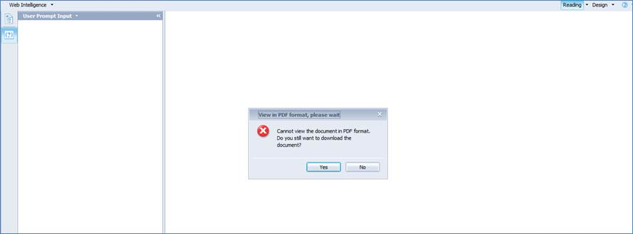
Select No in the message box
Click on the drop-down next to Reading (located on the upper right corner)
Switch to HTML as seen below
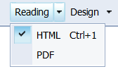
The reports will now finish in EXCEL format.

Chrome

In Chrome, the popup blockers for https://www.e-wef.org must be turned off. Here are the instructions for configuring the popup blocker.
Right click the “X: and select always allow pop-up from our site e-wef.org. Please see the screenshot below for the location of the popup blocker control. You will just need to do this setup one time per a computer. NOTE: You won’t see the “X” box unless you try and run the report, then it appears to tell you that it blocked a popup box

Internet Explorer 11 or Bing

Internet Explorer (IE) 11 is no longer supported by Microsoft; however, many people still use it. The process for IE and Bing is more complicated than the other browsers. We recommend using Firefox or Chrome browsers instead; however, if IE or Bing are the only options you have available, please follow the instructions below.
- You will need to setup the site as a protected site. You only need to do this once for each computer you run the reports on.
  - Click on Tools
  - Click on Compatibility View Settings
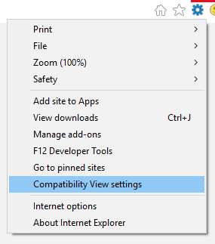

  - Add the following sites
http://wefprod2.personifycloud.com
https://www.e-wef.org

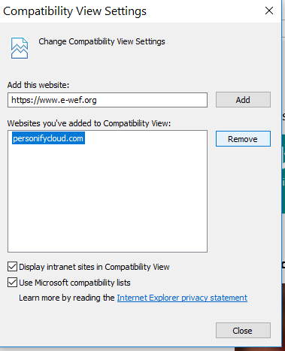

  - Close your browser.

IE (11) also have a pop-up blocker and it appears at the bottom page when you try to run the report.
Click on drop down next to Options for this site then select “always allow”
- Select the report and enter in the MA password and other criteria.
- Report run, hangs and never finish (this is the flaw we mentioned on IE 11 browser)
- Once the report appears like this on the screen
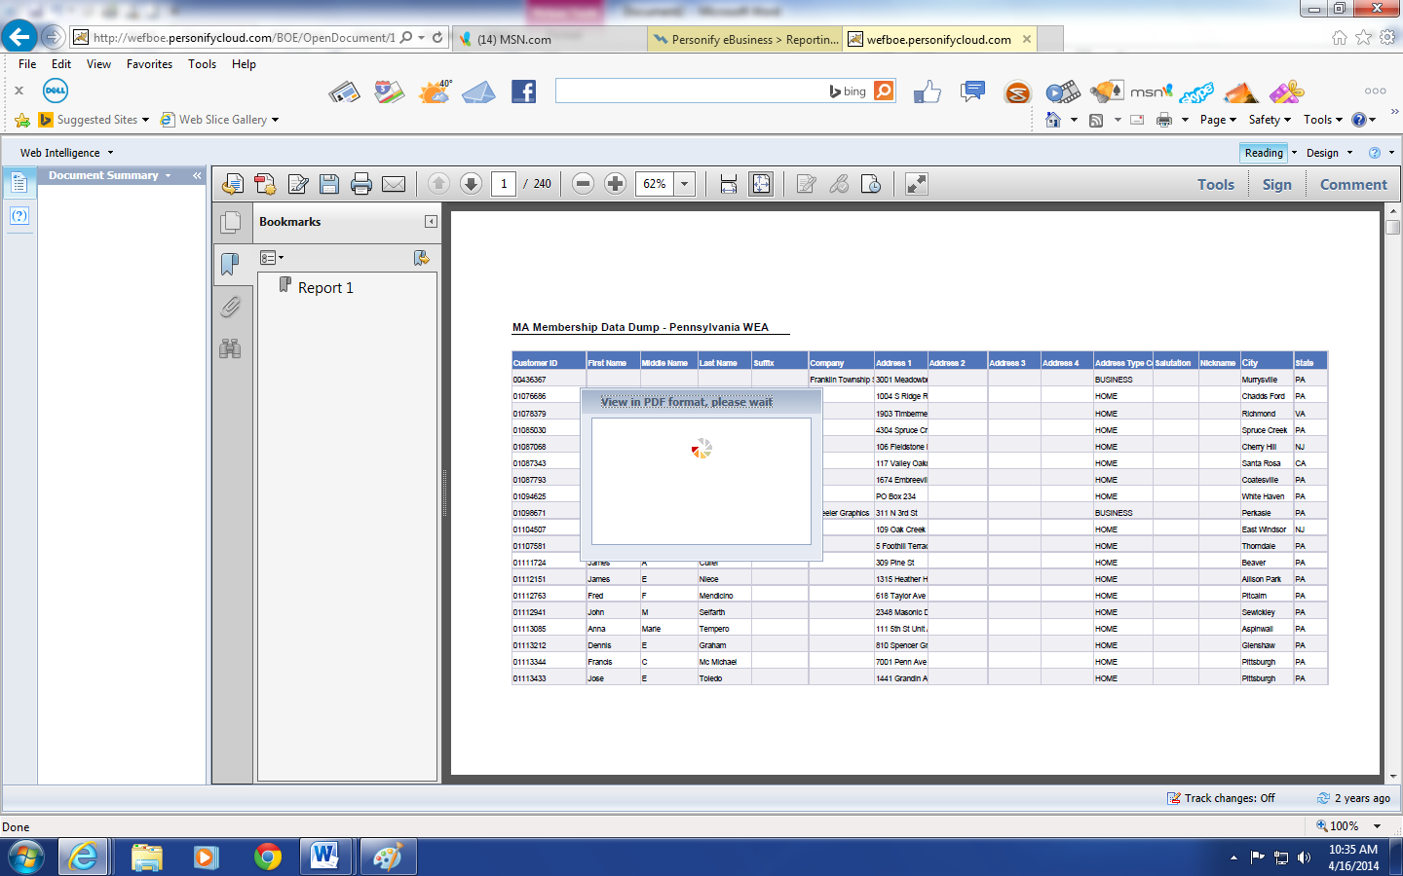
Press ESC then click on drop-down next to Reading option circled below, switch to HTML

- Now the report completes and you are ready to export. The export to file option is the 

- Click on the down arrow next to export shortcut
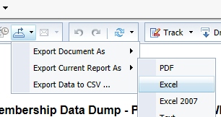

MA Rebate Reports

Please note that the rebate reports are not to be used for member reconciliation, only for payment reconciliation.
To access rebate files, click the second option under Reporting Tab “WEF Preview MA Rebate Process”
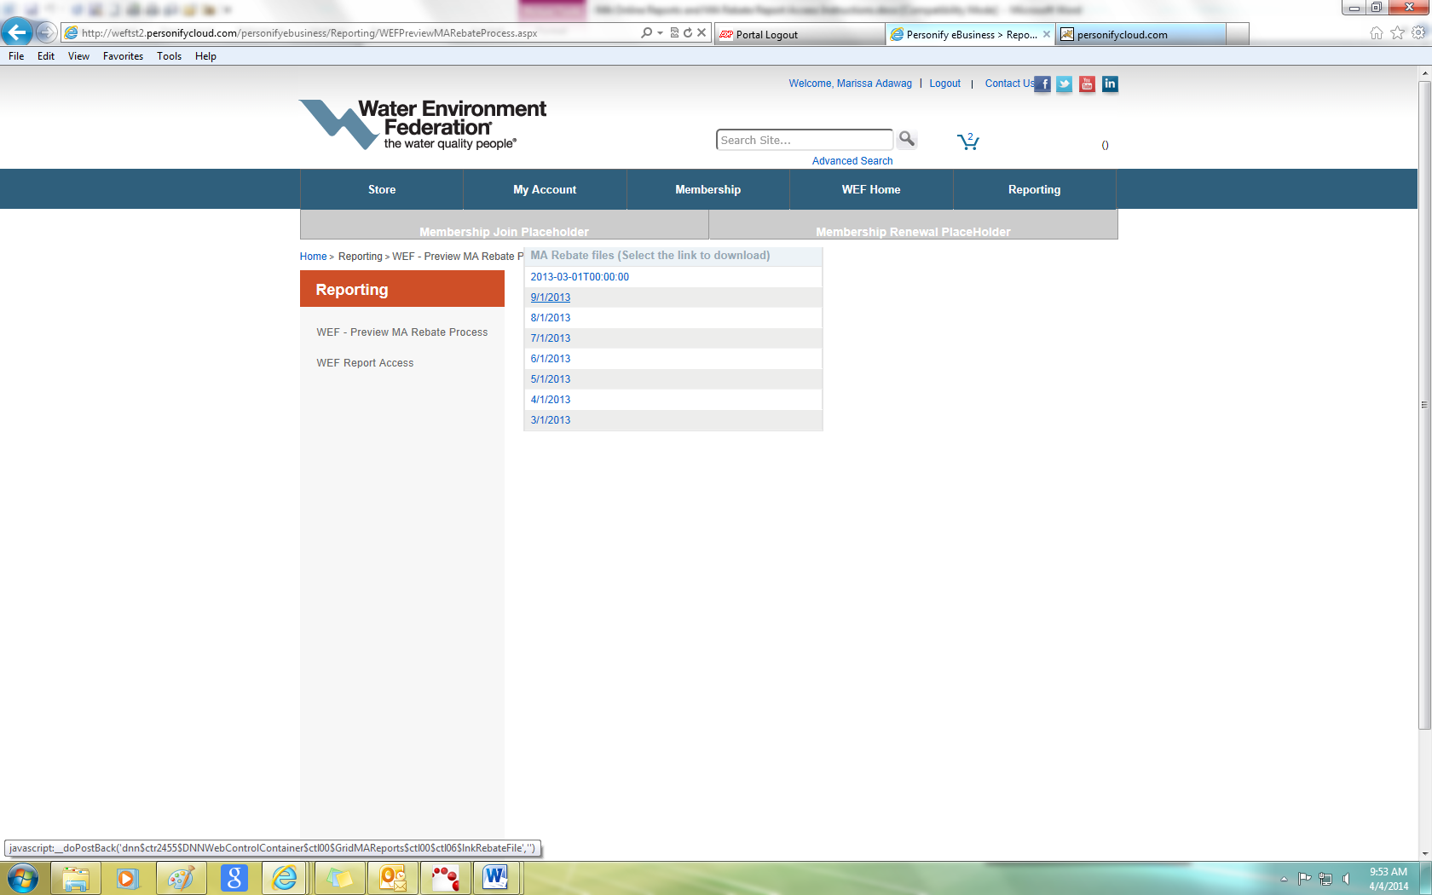
Double click on the file to open it. Report can be save in excel or csv format.

Membership Directory
WEF has given MA (Member Association) key staff to search for a member even if they are part of their member association.

Instructions
- Double click the Membership Directory Option
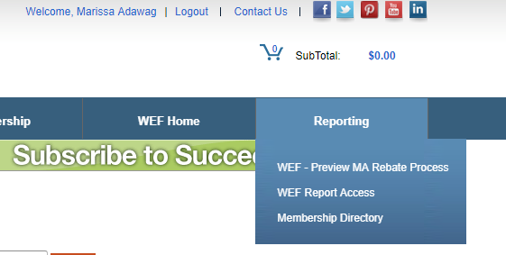
- Search can be done using either of the fields below:
  - Name
  - Employer
  - City
  - Email
  - State

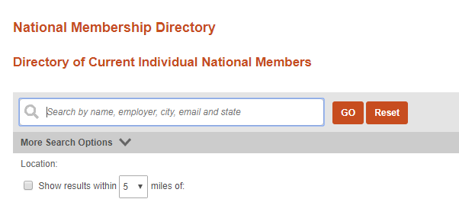
- Using email search “madawag@wef.org” returns the following record
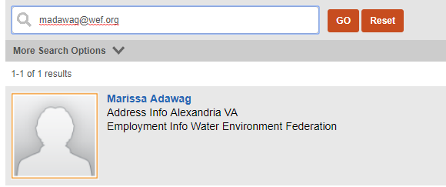

- Search by first name and location can be done as follows
- Enter first name
- Use the More Search Options , check box “Show results within 5 miles (note: this is default)
- Under Specific Location, enter the state name (cannot take abbreviation on this field)
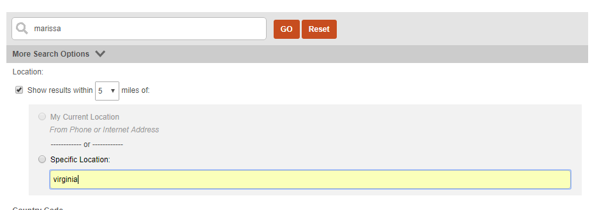

Displayed output below
