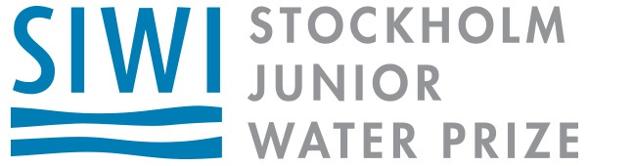

U.S. Stockholm Junior Water Prize

State Contact:
State Organizer’s Name Here

Sponsoring the [State Name] Stockholm Junior Water Prize

Background
The Stockholm Junior Water Prize (SJWP) is the most prestigious youth award in the world for a water-related science project. The program encourages student interest in water and the environment and helps raise awareness of global water issues—and in the process it has led to the discovery of major breakthroughs in water research.

More than 30 countries participate in the international competition each year in Stockholm, Sweden, which brings together some of the world’s brightest young scientist. As a symbol of the award’s prestige, the awards ceremony culminates in a presentation by the H.R.H Crown Princess Victoria of Sweden.

The U.S. representative is selected through a series of competitions at the regional, state, and national level, and involves more than 1,500 students. The U.S. national competition is a 2-day educational event that focuses on the importance of water and involves students from all 50 states, Washington D.C., Puerto Rico, and the U.S. Virgin Islands.

Our Sponsorship Program
The U.S. SJWP competition is organized by the Water Environment Federation (WEF) and its Member Associations across the country. We provide a foundation for program funding and support, and reach out to other sponsors who see value in this important program. Sponsor support is vital to the SJWP program and helps fund the regional, state, and U.S. competitions, and ultimately helps to promote the importance of clean, sustainable water.

[Your State] State Competition Sponsor Benefits
As a sponsor, you have a direct link to this program and the positive impact it has on the educational community. In addition, [MA name] offers the following benefits:

- Example 1 – Logo placement and recognition on MA website in SJWP or public education section

- Example 2 – Logo placement and recognition in MA newsletter

- Example 3 – Logo placement and recognition on materials at MA annual conference

- Example 4 – Logo placement and recognition on MA website in SJWP or public education section
- Example 5 – Recognition and invitation to participate in state plaque presentation

