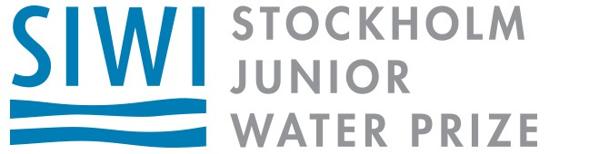

Dear [Contact Name],

The Stockholm Junior Water Prize is an international science competition that challenges high school students to address the issues facing our water resources. In the United States, more than 1,500 students participate through competitions at the regional, state, and national level, and funding is critical to continue to foster their interest in protecting the water environment.

I am writing to you in the hopes that [Potential Sponsor’s Name] will consider supporting the [State] Stockholm Junior Water Prize (SJWP) competition. As the state competition organizer, I have seen the impact this program has on our youth and witnessed the scientific breakthroughs that these young people are making. [Potential Sponsor’s Name]’s support would perpetuate this positive influence in our local community and help fuel environmental improvements.

[Your Member Association] is currently seeking local sponsors to contribute [$X to $X] to sponsor the state SJWP program. These funds will help provide travel to the national competition and other incentives that award students for their achievement. As a local sponsor, [Potential Sponsor’s Name] would receive [List of Sponsor Benefits: recognition at MA’s annual conference, recognition in newsletter, etc.]

To learn more about the program, please visit www.SJWP.org. I will contact you shortly to discuss any interest your organization might have in this opportunity, or you can email or call me directly.

Sincerely,

[Your Name]
SJWP [State] Organizer
[You’re Member Association]
[Your Contact Information]

