
The water sector workforce is the front line of public health and environmental protection and is vital to sustaining our critical water infrastructure investments. Working with federal agencies and state, local, and tribal partners, we will take actions that encourage innovative workforce practices at water systems, highlight the value water protection specialists provide every day, and help make water a career of choice through education and sustained public outreach. — Andrew Wheeler, Administrator, U.S. EPA, October 2020

America’s Water Sector Workforce Initiative:

A Call to Action
Contents
Foreword 1
Introduction 2
1: Provide Federal Leadership to Create National Momentum and Coordinate Efforts 8
1.1 A History of Successful Collaborations Within the Federal Government 8
1.2 Federal Agency Collaboration to Support the Water Workforce 8
2: Partner to Build the Water Workforce of the Future 16
2.1 EPA’s Workforce Collaboration with Associations and Utilities 17
2.2 EPA’s Water Workforce Collaboration with Tribes 23
2.3 EPA’s Workforce Collaboration with States 24
3: Bolster Education and Outreach: Making Water a Career of Choice 25
3.1 Administer New Workforce Grant Program 25
3.2 Engage Schools and Educational Organizations to Bolster Student Awareness 25
3.3 Focus on Underserved Communities and Water Workforce Diversity 26
Looking Ahead 29
Appendix 1: Table of Actions from America’s Water Workforce Initiative 30

___________________________________________________________________________________________
Disclaimer - The Water Workforce Initiative is not a budget document and does not imply approval for any specific action under Executive Order 12866 or the Paperwork Reduction Act. All federal government activities included in the Initiative are subject to budgetary constraints, interagency processes, stakeholder input and other approvals, including the weighing of priorities and available resources by the Administration in formulating its annual budget and by Congress in legislating appropriations. This document is not intended, nor can it be relied upon, to create any rights enforceable by any party in litigation with the United States. This document does not impose legally binding requirements. Mention of case studies, public, private, or nonprofit entities, trade names or commercial products or services in this document does not and should not be construed to constitute an endorsement or recommendation of any such product or service for use in any manner.



Foreword
Ensuring that all Americans have access to clean water is a top priority for EPA. Each day communities and businesses depend on clean and safe water for daily routines that can range from drinking a glass of water to irrigating the crops that support our food supply. Behind each of these daily routines are the hundreds of thousands of skilled workers that comprise America’s Water Sector Workforce. These workers provide us with clean drinking water and safe wastewater treatment every day.
One of the major challenges facing our nation is the critical and unprecedented staff shortage in the water workforce that operates and maintains our essential drinking water and wastewater infrastructure. In the next five to ten years, water sector workers will be eligible to retire at levels that will stress our ability to operate this critical infrastructure. The clean and safe water and the way of life we have come to enjoy in this country cannot be sustained without our water protection specialists. We must address this pending shortage with focused engagement at all levels of government and our public and private water sector partners.
America’s Water Workforce Initiative is a first of its kind and reflects a commitment by EPA and our federal partners to work with states, tribes, utilities, local governments, and other stakeholders across the water sector to ensure that our workforce is strong, diverse, and resilient, and attracts talented individuals from many different backgrounds. The Initiative also emphasizes the need to recognize our water workforce for the vital service they provide to our communities every day. It convenes the resources across the government and industry by bringing discrete efforts together under one umbrella to more effectively bolster water sector careers and reach the next generation of water protection specialists.
This Initiative is designed to be a living endeavor that will expand as collaborating partners learn and adjust efforts to fully realize the vision we have for our valuable water workforce. EPA looks forward to capturing innovative ideas and collaborative actions through this Initiative so the Agency can take meaningful steps to ensure America has a strong water sector workforce for generations to come.
Please join EPA and our water sector workforce partners in this effort!
David Ross
Assistant Administrator, Office of Water
U.S. Environmental Protection Agency

Introduction

America’s Water Sector Workforce Initiative
Cities and communities across the country are facing critical staffing shortages for the operation and maintenance of essential drinking water and wastewater infrastructure. Approximately one-third of drinking water and wastewater operators in the U.S. will be eligible to retire in the next 10 years and the water sector has been facing challenges with recruitment and retention of the skilled workers required for jobs in today’s high-tech environment. Due to the scale of this challenge and the implications for environmental and public health protections, collaboration to find solutions across federal, state, tribal and local governments as well as public utilities, the private sector, water sector associations, community groups and educational institutions is essential. The identification of these challenges and implications as well as the need for a collaborative response has led the U.S. Environmental Protection Agency (EPA) to launch America’s Water Sector Workforce Initiative (the Initiative).
EPA is not alone in recognizing the need to act quickly to ensure the future sustainability of this sector. Congress also clearly recognized the need to support our water protection specialists and to do so in a collaborative way. The American Water Infrastructure Act (AWIA), enacted by Congress and signed into law by President Trump in October 2018, emphasized the importance of the water workforce. Importantly, AWIA highlighted that water and wastewater utilities provide a unique opportunity for access to stable, high-quality careers, and that investment in the development of local workers can strengthen communities and ensure a strong pipeline of skilled and diverse workers for today and tomorrow. Specifically, Section 4304 of AWIA recognizes and addresses the workforce concerns by establishing a competitive grant program that promotes water utility workforce development and increases public awareness of water utilities and associated careers.
The Initiative embraces the collaborative approach highlighted by both EPA and Congress to address the challenges facing America’s water workforce and ensure the resiliency of this vital sector. The Initiative reflects a commitment by EPA and our federal partners to work with other stakeholders across the water sector to ensure that our workforce is strong, diverse and resilient, and recognized by the public for the vital service they provide to our communities every day. It convenes the resources across the government and the water sector by bringing discrete efforts together under one umbrella to more effectively bolster water careers and reach the next generation of the nation’s water protection specialists.
Going forward, EPA and our partners pledge our support to achieve our collective vision of a trained, motivated, resilient and diverse water workforce that is ready, able and valued for providing clean and safe water to our communities. EPA will not only work with the many partners included in this draft, but also seeks to bring in other partners who are committed to bolstering our critically important water workforce.

The Impact of a Declining Water Workforce
Every day in communities across our nation, the dedicated workers who operate and maintain over 150,000 public drinking water and wastewater systems ensure that our water is clean and safe for hundreds of millions of Americans. These “water protection specialists” are critical to the safety and well-being of our communities and serve as the foundation for virtually all aspects of our society. Unfortunately, the nation is beginning to encounter critical and unprecedented staffing shortages in the water workforce that operates and maintains the country’s essential drinking water and wastewater infrastructure. The median age of water employees is 48 years and 30 to 50 percent of these workers will be eligible to retire within the next 5 to 10 years (Dickerson and Butler, 2018). The Government Accountability Office (GAO) and Brookings Institution reports both came to similar conclusions in 2018 and utility leaders across the country are echoing this concern. At the same time, challenges such as emerging-contaminants, aging infrastructure, water shortages, cybersecurity and rapidly changing treatment technologies and processes are placing greater demands on our drinking water and wastewater utilities. As this water system environment evolves, a growing number of service providers will also need water protection specialists with the skillsets and the training to deal with more complex issues like the use of innovative technologies, water reuse, and other emerging challenges.
Without a sufficient water workforce, water utilities will not be able to meet national drinking water and water quality standards. Recreational, economic, and other benefits associated with clean water resources could be diminished. In addition, water utilities would not have sufficient staff to properly operate and maintain existing or future critical water infrastructure investments. For drinking water alone there are over one million distribution pipes in the U.S., and according to the American Society of Civil Engineers (ASCE, 2017a) an estimated 240,000 water main breaks occur each year that result in a loss of over two trillion gallons of treated drinking water. Without water protection specialists to make the necessary repairs for drinking water distribution pipes, Americans will not have drinking water when they turn on the tap. According to ASCE (2017b), almost 800,000 miles of public sewers and 500,000 miles of private sewers connect to public sewer lines. Without water protection specialists, there would be no one to repair conveyances when structural failure, blockages, and overflows occur.

Resiliency and the Technologically Competent Water Workforce
Every day, water service providers tackle complex challenges such as aging water infrastructure, extreme weather events, water shortages, rising costs, increasing customer demands, and cyber security. Water sector utilities serve as “anchor institutions” in their communities and are implementing new and exciting technologies to address these pressing challenges. These advancements are critical to the overall resilience and sustainability of water utilities as well as the water workforce of the future. The necessary technologies required to run today’s water utilities are wide-ranging and complex. They include advanced monitoring and treatment technologies and sophisticated information management systems. Some examples include:
- Smart Systems: Monitoring technologies such as improved water quality sensor technology, remote sensing, and satellite imagery allow utilities to collect, manage, and analyze data to make accurate and optimal decisions to better serve the community. Smart technologies can provide critical, real‐time information that allows water utility managers to make important decisions to minimize potential service disruptions, enhance economic efficiencies, better manage assets, respond to emergencies, and improve public health. Furthermore, the information helps to improve coordination among water utilities and facilitate rapid collaborative response when needed.
- Treatment Technologies/Processes: Advancements in treatment technologies and processes help water service providers deliver safe drinking water to their communities and treat wastewater to protect our rivers, lakes, and streams. Examples of advancements include the development of biogas generators, net zero systems, nutrient recovery, and green infrastructure. For instance, net zero systems aim to consume only as much energy as is produced, achieving a sustainable balance between water availability and demand and eliminating solid waste sent to landfills. Net zero and net positive (NZ/NP) strategies emphasize taking a systems approach to reduce water, energy, and waste footprints in installations and communities. These strategies provide long-term solutions for sustainability and resilience by meeting the environmental objectives of clean air and water, while ensuring the long-term viability of resources is maintained and improved. Another example of treatment technology/process advancement in the water sector is on potable and non-potable water reuse. It plays a crucial role in protecting our water and addressing water scarcity and sustainability.
- Information System Management: A robust information system management program that supports operations, asset management, and cybersecurity is now more important than ever in the water sector to protect against system service disruption and the leaking of sensitive operational, employee, or customer information. Cybersecurity attacks cause significant disruption to critical utility process operations and business operations, jeopardizing the core mission of providing safe and clean water. Having a workforce that can effectively establish a secure information system and implement cybersecurity best practices is critical for water and wastewater utilities. Cyber-attacks on water or wastewater utility business enterprise or process control systems can potentially upset treatment and conveyance processes, compromise utility email and billing systems with customers’ personal data or credit card information and disable business enterprise or process control operations. Having a workforce that is trained in implementing a strong information management and cybersecurity program is crucial to safeguarding the integrity of process control systems and sensitive utility and customer information. This will ensure the ability of water and wastewater utilities to provide uninterrupted clean and safe water to their customers.
As the water system operating environment evolves to incorporate these technology advancements, there is a growing need to train and employ water protection specialists with a high degree of technological competence to make data driven decisions and to track all aspects of utility operations based on up-to-date and accurate information. In addition to water operators, the growing role of technology in day-to-day operations will continue to expand the role of engineers, information technology (IT), and security specialists, helping the water sector attract more technologically competent workers. At the same time, this shift will require training and re-training for existing workers in partnership with educational organizations to ensure their skillsets allow them to operate within an increasingly complex work environment.
To leverage technology innovation and create a more resilient water sector future, the water sector should make significant investments in technology education through training, operator certification, apprentice programs and other means. This education should focus on the use of digital tools that will enable workers to employ activities like digital sampling based on current conditions, asset management, and gap assessments to help utility managers improve worker competence. Investing in these workforce skills of the future will build a more resilient and adaptable workforce ready to meet the challenges and opportunities of the 21st century water economy.

The Case for and Challenges Associated with Ensuring a Robust and Diverse Sector of Water Protection Specialists – Opportunity, Innovation, and Rewarding Careers
Water Workforce Case Study: Resilience in the Face of the COVID 19 Pandemic
Charlotte Water is the largest public water and wastewater utility in the Carolinas, serving more than a million​ customers in the City of Charlotte and greater Mecklenburg County – including six towns. Charlotte Water has a diverse workforce of 1,000 people with operations spanning across 17 locations. This includes 5 Water Resource Recovery Facilities, 3 Water Treatment Plants, over 4,000 miles of both Collection and Distribution system lines, and over 300,000 service connections.

Like so many other utilities, Charlotte Water met the challenges associated with the COVID-19 pandemic by taking several key measures to ensure its workers remained safe and continued to provide the high-quality service their customers have come to expect. Some of the key measures Charlotte Water implemented include:

- Providing staggered work shifts
- Giving premium pay to frontline workers
- Allowing telework for those who could work from home
- Providing virtual training – both technical and life skills
- Ensuring that workers had adequate PPE and making hand sanitizer available
- Providing take home meals to the families of frontline employees
- Implementing an Incident Command System for the Emergency Operations Center
- Supporting other City Departments as needed with resources such as vehicles and hand sanitizer

As Jackie Jarrell, Interim Deputy Director at Charlotte Water, states, “our department continues to be committed to developing our employees by providing growth and development opportunities through training, leadership development programs, career pathing and job shadowing, and the maintenance of individual professional certifications. We’re also committed to providing opportunities to individuals in our community with barriers to employment. That includes our Apprenticeship and Pipeline Academy programs. Both programs provide an opportunity for Charlotte Water to develop a pipeline of future workers with the skills and abilities needed to fill entry-level positions in water/wastewater and provide the training and experience needed for a successful career at Charlotte Water.”
Jobs in the water sector provide stable employment, meaningful careers, useful technical skills (including using innovative technologies), and a chance to make a real difference in our communities. The direct and ancillary workforce that supports drinking water and wastewater utilities in the U.S. represents employment opportunities in every community across the country. In many instances, employment in the water industry is recession proof since drinking water and wastewater services are typically supported by local communities and municipalities and are considered critical to maintaining public health. Water utility workers number in the hundreds of thousands. The 2018 Brookings Institution report concluded that over 1.7 million U.S. workers with varying specialties are directly involved in designing, constructing, operating and managing water infrastructure, with over 200 different occupations including skilled trades, technology, engineering, finance, management, and administrative professions. The 2018 GAO report, which assessed data from the Department of Labor’s Bureau of Labor Statistics and included a narrow set of job categories that excluded trades such as plumbers and consultants, estimated a total water workforce of about half a million. No matter how you parse it, the industry that keeps our water safe and clean relies on a vast number of dedicated and committed people. And because 30 to 50 percent of water employees are eligible to retire in the next 5 to 10 years, there will be many opportunities for finding jobs in the water sector in the coming years. In addition, according to the 2018 Brookings Institution report, occupations in the water sector pay well, with hourly wages exceeding the national average, across various sectors and particularly for jobs in the lower income scale. When compared to all workers across the U.S., wages for water sector employees are generally more competitive than the market average, earning average hourly wages that range between $14.01 to $17.67 for the 10th and 25th percentiles respectively, as compared to $9.27 and $11.60 for all workers. The types of jobs also vary greatly, as do the utilities offering these jobs. Major metropolitan utilities can employ hundreds of people while medium and smaller utilities work at a smaller scale. Websites such as Work-for-Water provide information on specific types of jobs that are available. The nature of water work is also changing, requiring greater digital technology skills and the use of innovative treatment technologies. As leaders in the water industry embrace sustainability and innovations in technology, energy, finance, and management, selecting a career in water offers a pathway to cutting-edge advances in digital technology, science and engineering for both new and seasoned workers.
An occupation in the water sector is a notable career choice that provides a meaningful sense of mission and a distinct connection to public service. By delivering clean, safe water, water protection specialists have positive and profound impacts on the health and wellbeing of everyday Americans and our environment. They have an opportunity to contribute to the vitality of their community and be a part of something bigger than themselves.
Ensuring the development and sustainability of a robust and diverse workforce in this sector, however, comes with a number of challenges. For instance, though these jobs generally offer competitive wages, systems in small and rural communities, as well as tribal communities, often face wage-related challenges that can inhibit recruitment and retention. Additionally, the water industry struggles with recruiting a diverse workforce with the full range of skills needed to tackle these important jobs and emerging challenges. The Brookings Institution report states that the water industry lacks both gender and racial diversity in various occupations, with some types of positions attracting few women and minority populations. Additionally, the wellbeing of local communities is impacted as eligible and interested citizens are not recruited or made aware of these important jobs that offer economic stability and rewarding work. Focused attention on raising awareness of opportunities and improving recruitment strategies is imperative.
The GAO and others have found that tribes, rural areas, and small towns may have particular challenges in recruiting and retaining staff. Several reasons include a lack of resources for developing and implementing workforce strategies and challenges in competing with other fields or larger utilities for wages. Rural areas and small towns often must operate with a smaller recruitment pool, and thus may require new strategies and efforts to raise awareness of the importance and availability of water sector jobs.

Action Areas of the Water Sector Workforce Initiative
The workforce challenges facing the water sector are a national priority for all Americans who rely on safe and clean water for our daily lives. These challenges are not new, nor will be they be addressed overnight or by one organization. Our collective success in meeting these challenges depends on bringing together dedicated stakeholders around a set of interrelated actions that focus on leadership, partnering, and outreach. This Initiative is organized around three interrelated action areas:
- Action Area 1: Provide federal leadership to create national momentum and coordinate efforts
- Action Area 2: Partner to build the water workforce of the future
- Action Area 3: Bolster education and outreach to make water a career of choice
EPA and our federal partners have made the commitment to work together through this Initiative to create national awareness and focused leadership that helps serve as a catalyst for developing a robust, highly skilled and sustainable water workforce. Importantly, there are many organizations in the water sector already taking leadership roles to support water protection specialists. We therefore remain fully committed to continue to partner and collaborate with non-federal entities, including associations, states, tribes, local governments and utilities. Together we can expand upon successful practices to promote innovative workforce development strategies at water, wastewater, and stormwater systems. Our partners have a long-term, direct and vested interest for ensuring the success of the Initiative.
Additionally, to bolster water careers, federal and non-federal entities also need to actively engage and work with educational, youth, and other community-based organizations to increase awareness, understanding, and pathways to water sector careers. These organizations can assist with targeted and sustained efforts to reach students and schools at all levels, including those in disadvantaged communities, as well as others seeking career changes, with information on the value and benefits of these jobs as well as accessible career pathways to access them. Details for each action within these areas are included below and included as Appendix 1. Appendix 2 describes some key past actions that have helped establish a strong foundation for moving forward. By working together on these action areas, government and industry can convene our collective resources to more effectively bolster the water sector career and reach the next generation of the nation’s water protection specialists.

BECOMING INVOLVED
EPA developed this Initiative to serve as the foundation for a living and growing effort to build and maintain a sustainable water workforce sector. As such, EPA is committed to continuing to build on the partnerships and actions identified in the Initiative and the Agency welcomes interested new partners to join us in this important endeavor. To capture progress made on the Initiative moving forward, EPA will convene both existing and new partners engaged in actions aligned with this initiative biannually and will publish updates to the Initiative annually. If you have suggestions on our actions or would like to propose an initiative to join EPA in working to ensure the sustainability of this vital workforce sector, you can contact the Agency at WaterSectorWorkforce@epa.gov.

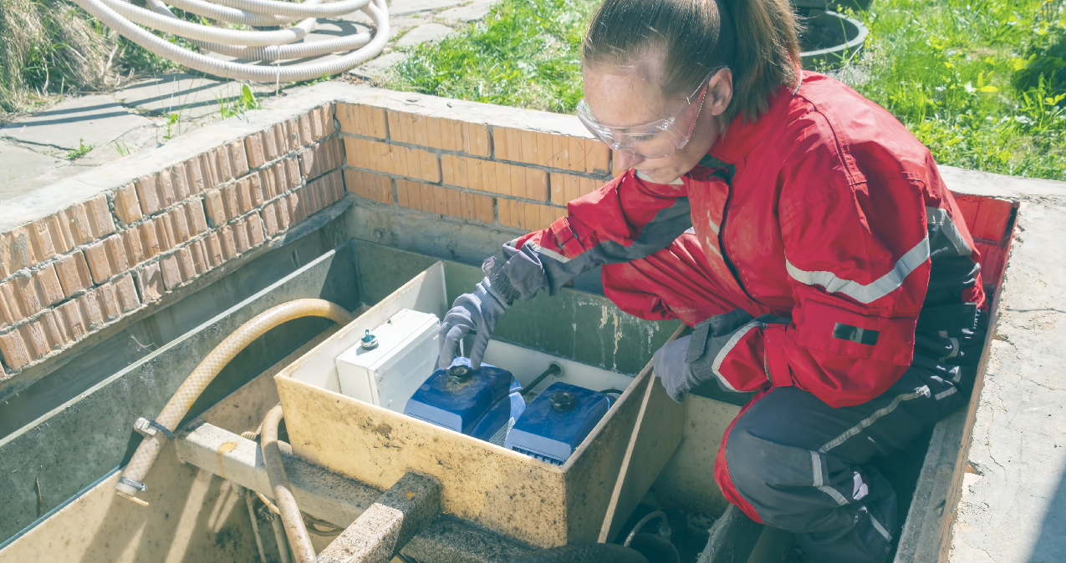

1: Provide Federal Leadership to Create National Momentum and Coordinate Efforts

1.1 A History of Successful Collaborations Within the Federal Government
The water workforce ensures that our homes, businesses, schools, daycares, hospitals, and other facilities have clean water that is used to perform day-to-day activities. Just as the community needs the support of water protection specialists, the water sector needs support across government agencies, industry, and associations. EPA and its participating federal agencies have enjoyed a strong history of successful collaboration on efforts to address water sector workforce needs.
In April 2019, EPA convened federal partner agencies to discuss collaboration across the federal government to continue to support the water sector workforce. The agencies assessed the accomplishments under the existing collaboration and identified new initiatives and additional efforts focused on the nation’s water protection specialists. We anticipate the number of federal partners will expand over time.

1.2 Federal Agency Collaboration to Support the Water Workforce
federal agency partnerships
The following list includes EPA’s current federal partners who have committed to assist the Agency in addressing the water workforce challenge:
- The Department of Education, Office of Career, Technical, and Adult Education (ED-OCTAE). ED-OCTAE administers programs that are related to adult education and literacy, career and technical education, and community colleges. ED-OCTAE is a critical, new partnership recently established by the agencies.
- The Department of Labor, Employment & Training Administration (DOL-ETA). DOL-ETA administers federal government job training and worker dislocation programs, federal grants to states for public employment service programs and unemployment insurance benefits. The DOL-ETA resources provide support for valuable hands-on learning opportunities, such as apprenticeship programs. In addition, DOL-ETA partners, such as the state and local Workforce Development Boards, provide a strong network of workforce specialists and experts that can provide local support to utilities across the country.
- The Department of Labor, Women's Bureau (DOL-WB). DOL-WB develops policies and standards and conducts inquiries to safeguard the interests of working women; advocates for their equality and economic security; and promotes quality work environments. DOL-WB can help to increase women’s representation in the water sector workforce.
- USDA’s Rural Utilities Service (RUS). RUS provides much-needed infrastructure and infrastructure improvements to rural communities. These include water and wastewater treatment, electric power and telecommunications services that help to expand economic opportunities and improve the quality of life for rural residents. RUS also funds technical assistance and training programs that promote workforce development and capacity building for water and wastewater operators and management.
- Veterans Affairs (VA) - Office of Transition and Economic Development (TED). TED convenes partners within and outside of the VA to provide Veterans access to the benefits and programs they need for a seamless transition from military service to civilian life. VA-TED will provide opportunities for the water sector to engage with and recruit future water professionals from many military communities, including Veterans, service members preparing to enter the civilian workforce, and military spouses.
- VA - Veteran Readiness and Employment (VR&E) Service (formerly Vocational Rehabilitation and Employment Service). VR&E helps Veterans with service-connected disabilities with job training, employment services and accommodations, resume development, and job seeking skills coaching, as needed. Collaboration with the VA-VR&E provides additional opportunities for the water sector to recruit Veterans and create pathways for them to enter the water sector.
Historical collaboration with many of these partners has provided a strong foundation for this Initiative. See Appendix 1 for a summary of current and future planned collaboration activities.
- Coordination with the Water Subcabinet on a Broader Water Workforce Initiative
In addition to the specific federal partner commitments highlighted above, EPA is currently coordinating with the “Water Subcabinet” on the development of a federal interagency framework to enhance the recruitment, training, and retention of professionals necessary to maintain the viability of a broader water workforce. The Water Subcabinet is composed of senior leadership from each of the primary federal agencies that oversee national water policy. This group promotes efficient and effective coordination of water-related matters across federal government, prioritizing actions to modernize and safeguard the nation’s water resources and infrastructure. While this broader water workforce initiative includes those professionals necessary to sustain drinking water and wastewater sectors, it also focuses on those challenges facing the water reuse, flood control, hydropower, water delivery and storage, and desalination sectors.
The Path Forward – Commitments for Continued Federal Collaboration
The challenges facing the water workforce are multifaceted and can range from ensuring that workforce training keeps pace with technological advancements to building connections to a future water protection specialist. The ongoing and planned actions in this section build on the foundation of collaborative outreach, making key connections between the water sector and potential career seekers, and resource development. The federal commitments listed below center around four primary themes – (a) recruiting a diverse and dedicated workforce, (b) training for the skills of tomorrow, (c) collaborating to understand, assess, and fulfill the workforce needs of the future, and (d) public outreach efforts.
Recruiting a diverse and dedicated workforce

Women in the Water Workforce
Research has shown that women tend to be underrepresented in the water sector. While this section addresses enhancing women’s participation in the water sector, Section 3.2 presents EPA’s actions to build an overall inclusive workforce. To promote women entering the water workforce, EPA is forging a new partnership with the DOL-Women’s Bureau to increase women’s advocate’s awareness of the water sector. The notable immediate actions and on-going collaboration that will take place include:
- The National Summit on Women in Apprenticeship
DOL-WB regularly hosts educational programs, such as last year’s National Summit on Women in Apprenticeship, to bring together a broad range of stakeholders and provides attendees an opportunity to learn from researchers, thought leaders, and practitioners; engage in dialogue and questions; and brainstorm ideas to address challenges facing women in accessing apprenticeship programs. EPA intends to promote women’s participation in the water workforce by encouraging water sector participation in the WB’s educational programs, such as the Summit.
The DOL-WB also plans to develop a resource guide that will highlight pre-apprenticeship and apprenticeship programs that have been successful in helping women access family-sustaining jobs and quality career pathways. Upon publication, EPA will promote the use of this valuable resource guide with the utilities and water sector partners. Additionally, in 2020, EPA plans to target Women’s Bureau stakeholder groups through a joint webinar to promote water sector career opportunities for women.
- The Women in Apprenticeship and Nontraditional Occupations (WANTO) Grant Program Best Practices
The WANTO grant program provides resources to expand industry pathways for women with a goal to “recruit, mentor, train, and retain more women in quality apprenticeship programs and pursue careers in manufacturing, infrastructure, cybersecurity, and health care, among other industries.” The Women’s Bureau is focused on expanding apprenticeships across all industries and sectors of the economy and advancing women’s access to these opportunities.
DOL-WB EPA plans to enhance awareness and encourage water sector participation in the WANTO grant program, specifically by connecting administrators of its apprenticeship programs with WANTO grantees to receive technical assistance and help in setting achievable goals to enroll women and minorities into the apprenticeship programs. In 2019, the WANTO grant program awarded nearly $1.5 million to three community-based organizations to increase women’s employment in apprenticeship programs and nontraditional occupations.

Veterans in the Water Workforce
Harnessing the dedication to public service that Veterans and their families have demonstrated, the water sector is a fulfilling career that allows these heroes to continue to serve their communities in their civilian roles. Furthermore, there are many transferrable skillsets between military duties and water sector operations. Federal programs and initiatives supporting the recruitment of these skilled professionals include:

The Veterans Affairs Economic Investment Initiatives
The VA-TED is planning a series of investment initiatives, including a job fair, to provide Veterans and military service members opportunities to learn about the services provided by the VA in different regions of the country. These initiatives include an economic development partnership roundtable discussion and a Hiring Our Heroes event (including a job fair) with the Chamber of Commerce.
EPA, the VA and water sector associations are also exploring further collaborative opportunities and activities such as the American Water Works Association (AWWA) Veterans Recruiting and Mentoring Initiatives (discussed further in Section 2.2).

EPA – VA-VR&E “Promoting a Veteran Workforce for the Water Sector” Memorandum of Understanding (MOU)
Under this MOU, VA-VR&E and EPA have been promoting Veteran transition into the water sector by utilizing the “From M.O.S. to J-O-B” guide to help with their transition. By early 2021, the two agencies will expand the MOU, provide outreach to pre-separation military service members, and connect with the Employment Coordinators at the VA Regional Offices to encourage Veteran participation in the water sector workforce. Under the MOU, the agencies are also exploring partnering and educating local water sector employers about VA-VR&E programs to help support Veterans entering new careers, including the water sector.
Water Workforce Case Study: A Great Choice for Our Veterans
Our Nation’s veterans are ideal candidates for a wide range of jobs in the water sector. They bring experience, discipline, and a strong sense of serving others. Kevin Carter, originally from Detroit, epitomizes the value these individuals bring to the job every day. Kevin served nine years in the U.S. Navy, five of them as a machinist mate on a nuclear-powered submarine that took him on three Western Pacific tours. Now he’s making a career in the water sector in Michigan after completing a 32-week internship with the San Diego County Water Authority.
“Onboard the USS Asheville, I worked with every system and every piece
of machinery – HVAC, refrigeration, pneumatic, hydraulic, diesel engines
and electric motors,” said Carter, a student member of the American Water
Works Association.
Carter, whose family has a long history of military service, grew up outside of Detroit. After his first year at the University of Michigan, he enlisted in the Navy to develop a clearer vision of what he wanted to do with his life. “It was the best thing I could have done,” he said. “I visited 22 countries before I was 22 years old. I wouldn’t trade my time in the Navy for anything.”
After retiring from active duty, Carter worked in the private sector before joining Qualcomm Inc., in San Diego. He worked there for nearly nine years before being one of 5,000 employees laid off in a global downsizing in 2015. A fishing buddy of Carter’s – a wastewater operator – suggested he look at jobs in the water sector. “He gave me a tour of his facility and I thought, ‘this is kind of what I’m used to, it pays well, it’s pretty recession proof and you can make a career of it.’”
When Carter lived in San Diego, he took classes at Cuyamaca College and the Sacramento State Office of Water Programs before doing an internship. “It’s been a lot of fun, it really has,” he said. “In the water and wastewater community here, everybody knows everybody. It’s a nice, familiar feeling.”
He passed the first two levels of the water treatment operator certification exam and the first level of the wastewater operator certification exam. More recently, he also passed the Grade 2 wastewater operator exam. Many of the skills and values he developed in the Navy – like leadership, team support, camaraderie, safety – he
believes are useful in the water sector. “As vets, we’re halfway trained already. You just have to get us the rest of the way there. Give us an SOP (standard operating procedure) and a wrench and we’re good. You can count on us.”
Kevin Carter’s dreams paid off. He now lives in Michigan with his wife and daughter and works as a wastewater treatment operator for the city of Kalamazoo. He has found a great job and plans to “make a career of it and go as high as I can go.”

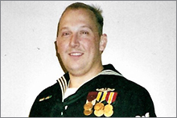
Kevin Carter, Wastewater Treatment Operator, City of Kalamazoo, MI


Kevin Carter with his family

Training for the Skills of tomorrow
Protecting America’s water requires highly skilled professionals to treat drinking water and wastewater and keep communities safe. Training and hands-on experiences are key to developing and retaining the necessary skillsets for water professionals. EPA is forging a new partnership with the Department of Education (ED) in a number of areas, and the notable immediate actions and on-going collaboration that will take place include:

Rural Community College Grant Application Convenings (RCCGA)
The ED-OCTAE’s RCCGA Convenings help rural community colleges identify, plan, and design projects for federal grant applications. Activities include facilitated workshops and the collection of information from a variety of federal agencies with upcoming opportunities. EPA, ED, and other federal partners will continue to collaborate and promote rural community college engagement with water sector partners through the RCCGA Convenings to increase jobs, income, and access to education in rural communities.

Education and Technical Training
In 2020 and beyond, EPA, in collaboration with ED and local education agencies, will work to identify states where water and wastewater training or educational programs could benefit from the utilization of Perkins funding, a federal program that supports the development of career and technical education programs.

The VA Non-Paid Work Experience Program (NPWE)
The VA-VR&E NPWE program provides eligible Veterans and Servicemembers with training and practical job experience in federal, state, or local government agencies. EPA will promote the use of the VA-VR&E NPWE program for employment opportunities in state or local government positions to address workforce needs in qualifying fields within the water sector. In 2020 and beyond, EPA will coordinate with water sector associations to facilitate presentation opportunities and distribute information to state and local employers who may utilize the NPWE program to meet government workforce needs.
Collaborating to understand, assess, and fulfill the workforce needs of the future
Gathering data, sharing best practices, and providing outreach and support to communities across America are critical in understanding the water sector workforce needs and shaping the solutions for the future water workforce.

The 2020 Drinking Water Infrastructure Needs Survey and Assessment (DWINSA)
The DWINSA is an assessment conducted every four years by EPA in collaboration with states and community water systems to estimate the Drinking Water State Revolving Fund eligible needs of systems for the next 20 years. For the first time, EPA is adding questions about the expected workforce needs of drinking water systems over the next 5 and 10 years to the 2020 DWINSA. The modifications to the DWINSA will help EPA and the water sector estimate the expected need for new workers with a better understanding of the different needs of organizations based on factors such as geographic regions and system size and type. DOL-ETA and EPA will collaborate in the development of these questions.

EPA’s Tribal Water Workforce Workgroup
EPA’s Tribal Water Workforce Workgroup seeks to find solutions tailored to the needs of tribal utilities. Tribal utilities may face unique challenges in meeting their workforce needs due to a variety of factors, including remote locations and difficulty finding necessary skills locally. The Tribal Water Workforce Workgroup includes other federal agencies (i.e., BIA, IHS, USDA, and HUD), tribal utility personnel, and technical assistance providers. The workgroup expects to publish a report in 2020 that will provide information and recommendations regarding successes in maintaining and supporting a tribal water workforce. EPA will use the report to continue to work with partners to address and expand support to the tribal water utility workforce.

The Water Operator Hiring and Contracting Guide
Many small and rural systems meet their workforce needs through operator sharing or hiring contract operators. This allows systems to gain the technical expertise needed while also reducing personnel costs. Finding the right fit for a system requires careful consideration of factors such as potential operator duties and required skillsets, or level of certification required. To help systems make informed decisions when hiring operators or contract operators, EPA has developed and published the Water Operator Hiring and Contracting Guide. This document is directed at small and/or rural systems and can help communities identify and recruit qualified personnel to meet their workforce needs. The document also offers information on the importance of a licensed/certified operator, roles and responsibilities of decision-makers and operators, questions for interviewing potential operators, and other critical resources.

State and Local Workforce Development Boards
Workforce Development Boards (WDBs) are part of the Public Workforce System, a network of federal, state and local offices that support economic expansion and develop the talent of the nation’s workforce. State and local WDBs serve as connectors between the DOL and local American Job Centers that deliver services to workers and employers. In coordination with the National Association of Workforce Boards and water association partners, EPA will develop outreach materials for water utilities that help communicate their workforce needs to state and local workforce development boards. The DOL-ETA will provide opportunities to enhance this outreach.

EPA - USDA “Promoting Sustainable Rural Water and Wastewater Systems” Memorandum of Agreement (MOA)
The renewal of this MOA in 2020 between EPA and USDA supports increasing the sustainability of drinking water and wastewater systems nationwide to ensure the protection of public health, water quality, and communities. Through the renewed MOA, the federal agencies and their partners will continue to raise awareness of rural water sector careers, train new operators, and develop tailored strategies to overcome specific challenges in rural communities. Through the previous MOA, the agencies developed the ‘Workshop in a Box’ training, which promotes workforce by encouraging local decision makers to consider succession planning and retention strategies.

USDA Apprenticeship Program
In 2018, USDA awarded a $6 million grant to NRWA for further development of its National Apprenticeship program. In 2020, a USDA grant for $5 million was awarded to continue this important work. In 2020 and 2021, USDA and EPA will identify new opportunities to promote the NRWA Apprenticeship Program and encourage both utility and apprentice participation in the program. NRWA will help connect the Apprenticeship Program administrators with DOL-WB WANTO grantees to promote diversity and inclusion of female and minority students in the apprenticeship program.
Public Outreach Efforts
Effective and modern communication to promote the water workforce will be integral to the success of these collaborative efforts. EPA and other federal agencies are committed to undertaking an expansive public outreach campaign as part of their collaborative efforts.

EPA’s Public Outreach Campaign
EPA is committed to work with federal and industry partners to develop and implement a public outreach strategy and campaign that will increase public awareness of the need and opportunities for work in the water sector. This campaign will leverage multiple platforms including social media, podcasts, news outlets and available websites.

Focused Rural Community Support
EPA and USDA will work to expand outreach to rural communities to promote resources for water utilities and elevate the water sector as a profession. Additionally, USDA continues to support water workforce development in rural communities through recognition of workforce development programs including positive scoring for USDA Technical Assistance and Training grant applicants who implement or encourage workforce development programs. Assessment criteria include additional points for applicants who “develop existing operator workforce and/or plan for new operators to enter the workforce.”

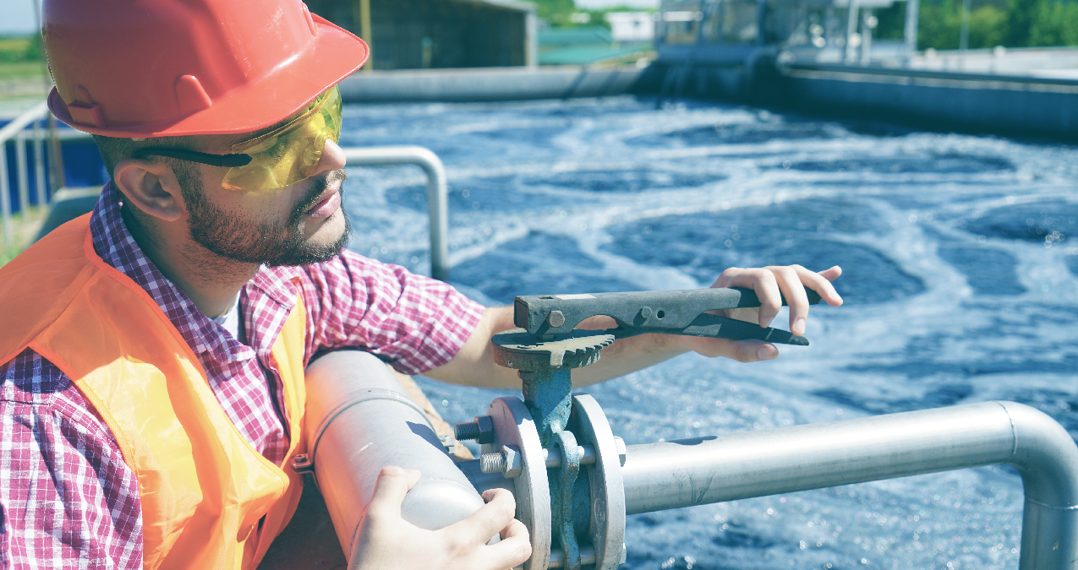

2: Partner to Build the Water Workforce of the Future
While federal leadership is a key component of this Initiative, all parties recognize the crucial role of non-federal organizations that work on behalf of the water protection specialists that operate and maintain our vital water and wastewater systems.
Action Area 2, Partner to Build the Water Sector Workforce of the Future, builds on EPA’s partnerships with federal agencies and describes a series of key commitments made by EPA and various non-federal partners to advance innovative and sustainable workforce practices by water utilities, wastewater utilities and the decentralized wastewater treatment industry. Organizations highlighted in this action area include water sector associations, local utilities, states, tribes and others.
“Water sector utilities are facing new workforce challenges requiring innovative solutions. Creating a sustainable and qualified workforce is critical to ensuring safe water for generations to come. Under this Initiative, AWWA is invested in working with EPA alongside a broad coalition to capture and promote best practices from our members and share them for implementation across the water industry.”
- David LaFrance, Chief Executive Officer, American Water Works Association (AWWA)
Several key events have helped form the basis for the commitments described under this action area. In November 2018, EPA and non-federal partners organized the National Water Sector Workforce Convening in Alexandria, Virginia. The purpose of this meeting was to share and build upon existing workforce efforts and describe a series of key actions to support water protection specialists. Also, EPA’s Tribal Water Workforce Workgroup began working together in June 2019. Additionally, in July 2019, representatives from the decentralized wastewater treatment sector convened a workforce and educational meeting in Nashville leading to actions to help workers that support decentralized systems. Finally, in August 2019, the Water Environment Federation (WEF) and the American Water Works Association (AWWA) sponsored a Symposium on Workforce to showcase innovative efforts by utilities to address local workforce challenges.

2.1 EPA’s Workforce Collaboration with Associations and Utilities
There are many activities underway across the water sector to address challenges in meeting future water workforce needs. The activities discussed below are examples of ongoing and future work.
EPA Workforce Activities

Utility Case Studies
At the November 2018 National Water Workforce Convening, participants stressed the importance of documenting and sharing successful workforce development strategies through a utilities-learning-from-utilities model. As a result, EPA, working closely with sector associations and utilities, is forming a series of water workforce utility case studies highlighting successful utility workforce programs and practices in:
- recruitment;
- retention;
- competency; and
- community partnerships.

EPA expects that these case studies will be available by the end of 2020.
Water Workforce Case Study: Developing Industry Leaders in Saco, Maine
Saco’s Water Resource Recovery Department (WRRD) serves a small community in southern Maine. WRRD believes that professional and personal development are crucial to the successful function of a utility. “Mainers all over the state use our oceans and rivers for recreation, as a food source, and often as a source of income. Protecting these waters is necessary and professional development helps us better understand our own process and stay ahead of changing standards,” says Matthew Szuter, Industrial Compliance Specialist at Saco WRRD. And they put their beliefs into practice by utilizing a robust education and professional development program for everyone within the utility, from interns to operators to management staff. Using a variety of different opportunities, Saco WRRD has become nationally recognized as a leader in professional development.
(Continued on the next page)
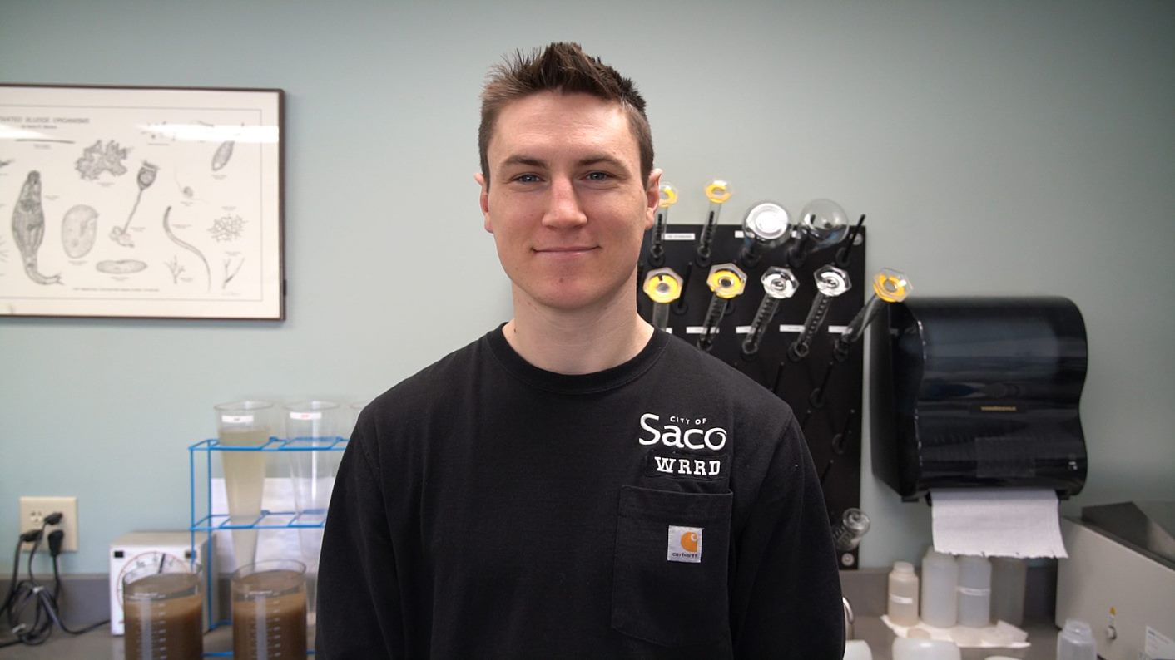
Figure 2 Riley Cobb, Lead Operator, Saco WRRD

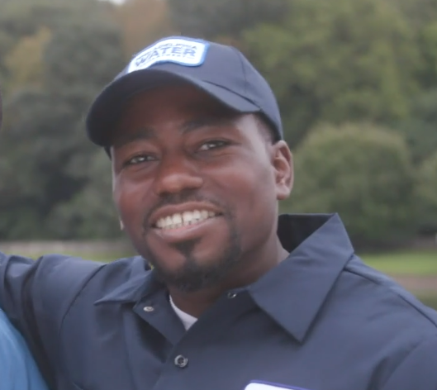
Figure 1 Aaron Kirkland, Crew Chief, Greenstorm Operations Unit

To see more of Aaron’s story, check out this video produced by the Philadelphia Water Department: https://vimeo.com/382437196
For more information on Power Corps Philadelphia see http://powercorpsphl.org/

Webinar Series
(Continued from previous page)
Saco WRRD offers educational opportunities to keep up with the latest wastewater technology, research, and treatment methods. This includes participation in the Operators Challenge, where the team from Maine competes against other states in different wastewater events. They also offer an Operators Exchange, where Saco operators can visit other utilities to learn about different operations and treatment methods. For professional development, Saco WRRD offers the opportunity to attend their Management Candidate School, an eleven-month program that trains future wastewater managers. Riley Cobb, who started at Saco WRRD as an intern and is now a Lead Operator, said the training is beneficial to “learn all the responsibilities and challenges managers have, and how effective communication is crucial to a healthy and successfully functioning workplace.”
The staff at Saco WRRD say that the culture there enables everyone to learn and grow. This is exactly why Stacy Johnson, who started as a lab technician, attended the Management Candidate School, and is now the Deputy Director of Saco WRRD, finds their program invaluable. She strongly encourages other utilities to help their staff flourish in the wastewater industry. She says, “it not only benefits your utility, but the drinking and wastewater industry as a whole.”
To learn more about Saco’s development program: https://youtu.be/rUjGtAu9yXI
To learn more about the Saco Water Resource Recovery Department: https://sacomaine.org/wrrd

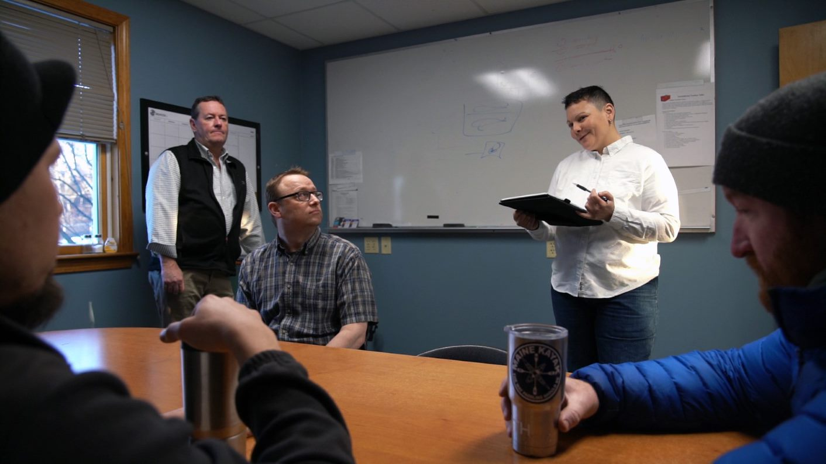
Figure 4 Stacy Johnson, Deputy Director, Saco WRRD

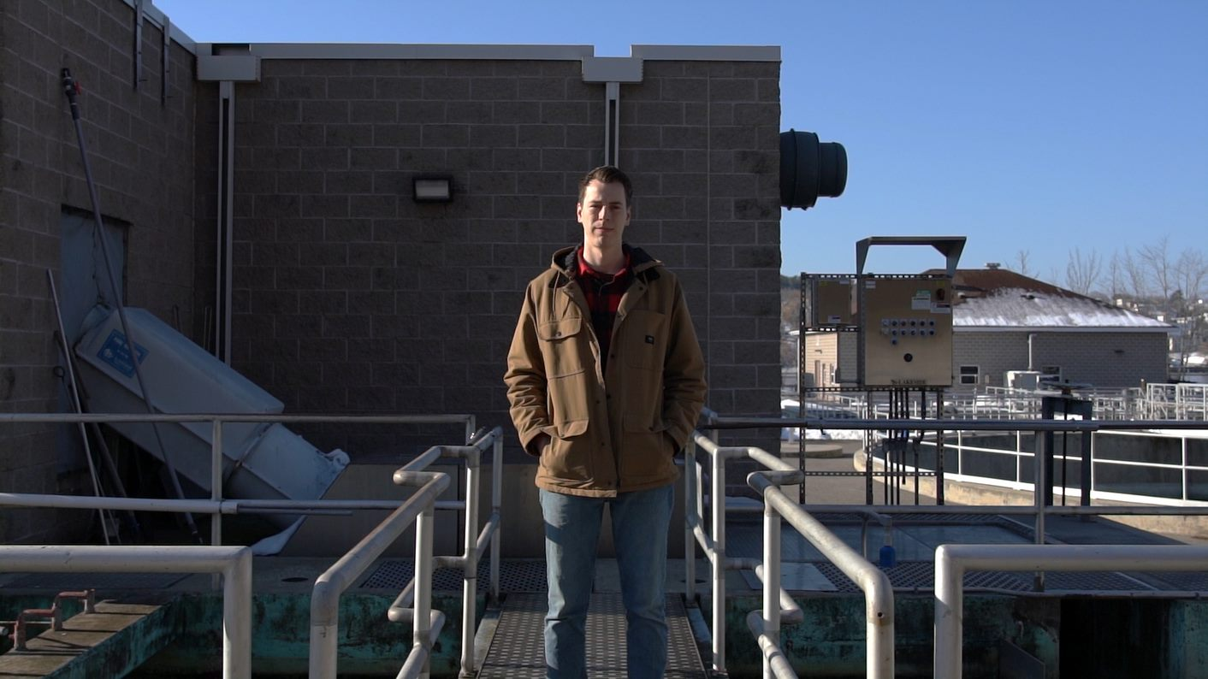
Figure 2 Matthew Szuter, Industrial Compliance Specialist, Saco WRRD

With sector associations and utility partners, EPA established the Creating the Water Workforce of the Future Webinar series to share successful models and practices focusing on recruitment, retention, training, and working with community organizations. The first webinar, held in October 2019, shared successes and lessons learned from the Hampton Roads Public Works Academy in the Hampton Roads Sanitation District (HRSD) in Virginia as they worked to build a pipeline of diverse and motivated staff in many parts of the organization. Several webinars have taken place covering such topics as diversity in the workplace, the role of state Workforce Boards, and partnerships with educational organizations. Future topics under consideration include building water workforce capacity in Opportunity Zones, and the use of innovative technologies.

Industry Dialogue on Operator Credentials
EPA, utilities, states, and tribes understand the importance of certified and credentialed operators and professionals. At the AWWA/WEF Transformative Issues Symposium on Workforce in August 2019, for example, an entire session focused on reimagining credentialing systems. A similar discussion was led by the Association of State Drinking Water Administrators (ASDWA) as part of their annual conference in October 2019. EPA will continue to participate in and contribute to the ongoing industry-led discussions on operator credentialing and portability of certifications.

Water Reuse Action Plan Workforce Goal

On February 27, 2020, EPA announced the release of the National Water Reuse Action Plan: Collaborative Implementation (the WRAP). One goal of the WRAP is to support a talented and dynamic water workforce and consistent with that goal, EPA will work with partners to identify and promote the ability to obtain workforce technical and operational skills necessary to implement effective water reuse programs. The WRAP can be found at https://www.epa.gov/waterreuse/water-reuse-action-plan.

Sharing EPA Workforce Tools

EPA is committed to sharing and promoting existing EPA water workforce tools through existing EPA websites, webinars, databases managed by partners such as Work for Water, and at conferences (both in-person and virtual). These include: The Workforce Training Programs Guide, the “Water You Waiting For?” videos, the comprehensive Knowledge Retention Tool, the Electronic Preventative Maintenance Cards, and the Small Water System Resource: Hiring or Contracting a Licensed/‌Certified Water Operator. These resources can be found here: https://www.epa.gov/dwcapacity/learn-about-workforce-issues.

Workforce Activities with Decentralized Wastewater Partners

The decentralized wastewater sector is an integral part of the nation’s wastewater infrastructure with approximately 20 percent of all U.S. households and about one third of new single-family homes being served by individual decentralized systems. EPA’s Decentralized Wastewater Memorandum of Understanding represents a shared commitment among EPA and 20 partner organizations to work collaboratively to improve decentralized performance and protect public health and water resources. One of the partnership’s core priorities is to expand mechanisms to address workforce, education, training, and research needs related to the decentralized wastewater industry.
Additionally, there has been growing focus on the significant opportunities to support and grow a decentralized workforce that designs, installs and maintains septic systems and other decentralized wastewater treatment systems. EPA is working with various partners to develop two documents: the first will map career pathways in the decentralized wastewater field, including occupational profiles for each career and job growth patterns/ projections, and the second will provide a landscape assessment on the credentialing/certification/licensing aspects of decentralized careers, and offer case studies on a few states that have successful frameworks for education and training. Both documents will be available in early 2021.

water sector Associations Workforce Activities

American Water Works Association (AWWA)
- www.WorkforWater.org (W4W)
AWWA will continue to collaborate with WEF to implement improvements to W4W, an internet landing page for those seeking jobs in the water sector. New local resources are being added and an information sharing site for workforce best practices is also being evaluated.

- Educational Assistance for Water Operators
AWWA will continue to fund and administer the One Operator Scholarship Program. This program provides water professionals with funding for certifications, training, conference attendance, tuition and books. More information is available at https://www.awwa.org/Water-Equation/One-AWWA-Operator-Scholarship. AWWA will also work with EPA and other partners to make information available through the Work for Water website located at https://www.workforwater.org/ on scholarship opportunities from other organizations.
- Increased Standardization and Reciprocity in Certification and Licensure
AWWA will sponsor four working groups to advance the effort to increase standardization and reciprocity in the water sector between states.
- Veterans Recruiting and Mentoring Initiative
AWWA (with WEF joining in 2020) will continue to develop and disseminate tools and resources to help organizations find, recruit, and hire Veterans and Transitioning Service Members – and to support a Network of Volunteer Liaisons (with coverage in all states by the end of 2020) to actively mentor and connect Veterans to the water sector.

- Facilitate Knowledge Transfer of Technology and Other Best Practices in the Industry
AWWA hosted a workshop on digitization of the water industry at the AWWA/WEF Utility Management Conference (March 2020) as well as a webinar on the impacts of COVID-19 on the water workforce (May 2020) and will continue to actively participate in discussions on this topic with EPA, WEF, and other partners.
- Engaging with Young Professionals (YP)
AWWA will work with EPA to host a listening session with a group of Young Professionals at the 2021 Utility Management Conference. The purpose of this session will be to solicit input on ways that AWWA, EPA, and others can better attract young professionals to careers in water.

Association of Metropolitan Water Agencies (AMWA)
- Executive Management Conferences
In response to continuing demand from water utility executives, AMWA will put workforce issues at the top of the agenda for its annual management conferences, drawing on the expertise of leading academics and consultants in the area of workforce development and bolstered by peer sharing of successful initiatives and lessons learned from top water utility managers.

National Association of Clean Water Agencies (NACWA)
- Water Sector Marketing Strategies
In collaboration with the US Water Alliance, the Water Agency Leaders Alliance, EPA and others, NACWA will help facilitate discussions on a strategy describing ways the water sector can better market itself and its opportunities to job seekers, as well as provide local utilities with guidance on how to best market themselves and their career opportunities to potential employees.
- Learning from Other Sectors
In collaboration with EPA and other water organizations, NACWA, in early 2021 will consider options for convening discussions with other sectors (transit, public works, etc.) to exchange best practices on how to recruit and retain talent in key public sector jobs.

National Rural Water Association (NRWA)

Apprenticeship Program
- NRWA will continue to expand its national Registered Apprentice program by providing technical assistance to state affiliate members to participate in the program.
- In 2021, NRWA will seek to expand the number of state affiliate members with active apprenticeship programs from 14 to 25 and to increase the number of registered apprentices nationwide from 219 to over 300. NRWA will help state affiliates connect with DOL-WB WANTO grantees to promote diversity and inclusion of female and minority students in the apprenticeship program.
- NRWA commits to strengthening its national registered apprenticeship program by transitioning the time-based program into a hybrid of time-based and competency training as an essential part of assessing an apprentice’s performance measures.
- As all statistics currently include larger cities that affect the national and local wage averages, NRWA will continue to work on the development of an accurate representation of rural water/wastewater occupations and work toward the goal of recognizing these as “in demand” occupations.

Outreach Materials
NRWA will continue to provide support and outreach materials, and conduct outreach efforts to:
- Engage youth in rural and small communities in order to educate the next generation of the career opportunities available in this industry.
- Expand efforts to promote an inclusive and diverse work environment, including those with disabilities.
- Foster mentoring opportunities for apprentices with NRWA Circuit Riders, state affiliate board members, neighboring systems, and local business leaders.

Rural Community Assistance Partnership (RCAP)

Summary Report

RCAP will identify job duties and skills applicable to the water workforce that will help ensure long-term success of new professionals entering the water industry. RCAP will provide training specifically to prepare water professionals for certification and to meet continuing education requirements for the safe operation of public water systems throughout the United States. This is and will continue to be done through the RCAP network of technical assistance providers. In response to COVID-19, RCAP has modified training materials to make them available virtually.

RCAP will update regulatory sections of the Operator Basics Training Series and provide this as a free downloadable resource for initial operator training.

RCAP is working with one its regional partners to provide an Operator-In-Training (OIT) program. The program will encompass a training series to help systems develop new operators.

Water Environment Federation (WEF)

Expand Workforce Efforts
WEF will lead, maintain, and expand existing WEF and partner efforts, such as In-Flow, WEF/AWWA WorkForWater.org, the National Green Infrastructure Certification Program (NGICP), operator programs, curriculum development, best-practices resources, and regional job placement coordination (using the BayWork model). To enhance the visibility of jobs in water quality sector and enhance the recognition of the triple-bottom line benefits of careers, WEF will:
- Support research, public outreach, and advocacy that promotes careers in water, and in particular to improve diversity and inclusion.
- Support curriculum development (including translations to Spanish, Mandarin, Vietnamese and other languages) for career and technical education to create a path for entry into operations positions.
- Support and assist the network of WEF Member Associations as they address workforce needs at the state and regional levels; WEF will convene and lead continued dialogue and collaboration within the water sector with the goal of achieving greater continuity and consistency in the state credentialing and licensing process.
- Convene regular opportunities to connect the water sector and external stakeholder groups to increase water workforce development coordination and knowledge sharing. Provide resources, such as best- practices reports, webinars, and conferences, to aid water workforce development efforts at the local, state, and federal levels.

Water Reuse Association (WateReuse)

Promote Training and Certification Resources
WateReuse will work with the Water Research Foundation and other partners to offer one or more web seminars to promote training and certification resources related to potable reuse as well as onsite systems.

Workforce Sessions
WateReuse will collaborate with EPA to offer sessions at the 2020 and 2021 WateReuse Symposia on workforce and operational skills for water reuse.

Outreach
WateReuse will promote reuse operator training opportunities through newsletters and other materials.

Water Research Foundation (WRF)

Water Research Roadmap
Working with EPA and other sector partners, WRF will prepare to hold a workshop in 2021 to develop a water workforce research roadmap. The potential scope of the workshop will include a pre-workshop survey with analysis of results, literature review, possible other information and data gathering efforts.

2.2 EPA’s Water Workforce Collaboration with Tribes
EPA and tribes work together to protect public health and the environment through implementation of environmental laws and programs, consistent with the federal trust responsibility and the government-to government relationship. As sovereign nations, tribes need to ensure that water protection specialists supporting infrastructure on tribal lands have the necessary training and skills to provide clean and safe water to their communities. EPA will continue to work closely with the tribes and other organizations supporting tribes to achieve this goal.

Tribal Water Workforce Workgroup
As discussed in Section 1.2, EPA’s Tribal Water Workforce Workgroup is supporting tribal water workforce development by identifying workforce challenges and potential solutions to address these challenges. The workgroup includes utility personnel from seven tribes, as well as technical assistance providers, tribal consortia, EPA, USDA, Bureau of Indian Affairs, Indian Health Service and the State of Alaska. The workgroup met several times in 2019 to discuss issues related to workforce challenges and to identify resource gaps. The findings will be captured in a final workgroup report scheduled to be completed in 2020.

InterTribal Council of Arizona Wastewater Certification Project
EPA has committed to participate in a technical assessment with the InterTribal Council of Arizona (ITCA) on a tribal wastewater operator certification project. The assessment aims to refine a test to measure a tribal wastewater operator’s knowledge of the federal rules and regulations that pertain to the operation and maintenance of wastewater collection systems and wastewater treatment facilities. The single 40-question, multiple choice, open-book exam will be administered in addition to or alongside the standardized Operator Certification Exams for credentialing of Wastewater Collection System Operators and Wastewater Treatment Facility Operators by ITCA. EPA and ITCA aim to develop and publish the updated test in 2021.

Tribal Drinking Water Certification Programs
EPA will support increased certification of water operators at tribal drinking water systems through enhanced use of tribal drinking water certification programs.

2.3 EPA’s Workforce Collaboration with States
In their role as co-regulators under the Clean Water and Safe Drinking Water Acts, states have primary responsibility to ensure that water operators have the training and credentials necessary to operate and maintain water and wastewater systems. EPA works closely with states and other partners in this area.

Operator Certification National Workshop
EPA has postponed the 2020 in-person Capacity Development and Operator Certification National Workshop until 2021. However, EPA hosted a series of virtual workshop sessions in August 2020 with presentations and discussions on capacity building and compliance for disadvantaged systems, use of asset management for financial resilience, and adaptive training, testing, and hiring techniques. These virtual sessions will enhance the in-person workshop scheduled for 2021.

Facilitate Discussions and Build Awareness at the State Level
EPA will continue to collaborate and facilitate discussions with state associations on water workforce and operator certification issues, and also participate on committees and workgroups focused on workforce development. EPA will work with states and others to help build awareness by utilities of the roles and opportunities available through other federal agencies and other organizations like the State and Local Workforce Boards. In September 2020, EPA facilitated and hosted a webinar featuring speakers from the National Association of Workforce Boards to help inform states and utilities about how workforce boards can help them achieve their water workforce development goals.

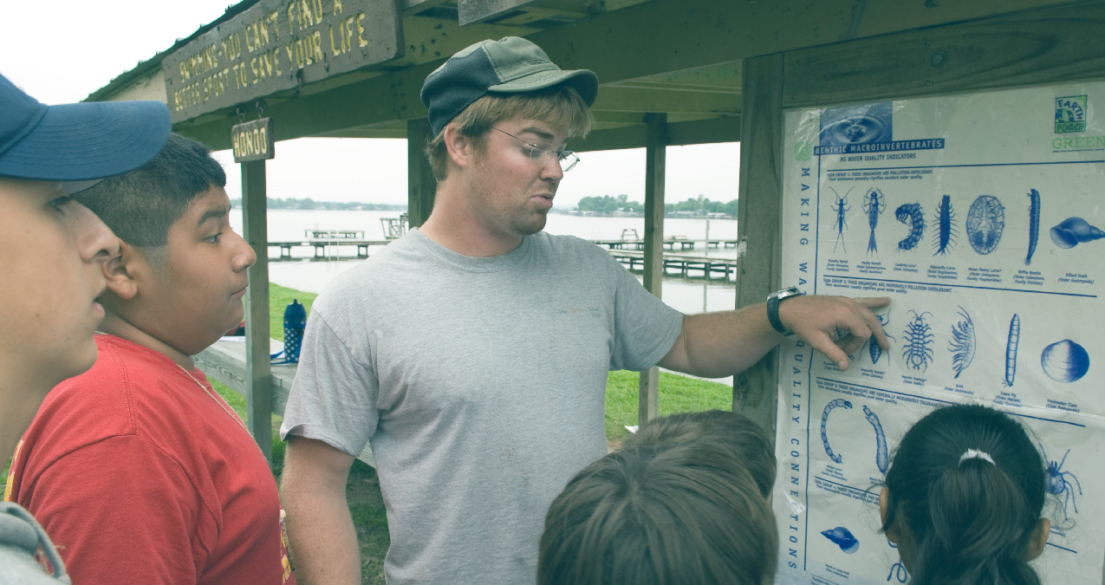

3: Bolster Education and Outreach: Making Water a Career of Choice
Underlying all aspects of this Initiative is the need to build a pipeline of future water protection specialists. Water sector jobs provide competitive wages, reliable employment and a way to truly make a difference in communities by protecting public health and the environment. However, many individuals are simply not aware of the value and opportunities for a career in the water workforce. Developing the next generation of water protection specialists requires early engagement of America’s youth to promote awareness of the promising career opportunities available in the water sector. Many community and educational programs as well as academic institutions have the capacity to connect youth and others to employment opportunities. We must strengthen our partnerships with these organizations and tap into their expertise. The sections below summarize actions EPA and other partners will take to reach schools, students, and teachers to support innovative community partnerships and to increase representation and diversity in the water sector.

3.1 Administer New Workforce Grant Program

Prepare to Implement AWIA-authorized Workforce Grant Program

In 2020, EPA is investing $1 million to implement a new grant program authorized under America’s Water Infrastructure Act (AWIA) in 2018. The program is designed to support water workforce education, training, and diversity by various organizations. Potential grant recipients include nonprofit professionals, nonprofit service organizations, nonprofit labor organizations, nonprofit community colleges, institutions of higher education, and other nonprofit training and educational institutions.

3.2 Engage Schools and Educational Organizations to Bolster Student Awareness

Promoting Water Careers through School Career Day Events
EPA is committed to engaging the next generation of leaders, including school-aged youth.
- Promotion of Water Careers at School Events
EPA will be reaching out to schools to share information about the water sector and will consider coordinating a Water Career Day event in a school along with local utility personnel to promote water sector careers in Fall 2020 and beyond.

Connecting the Next Generation of Professionals to the Water Sector
EPA is working to further the goal of ensuring a strong pipeline of skilled workers in the water and wastewater utilities sector.

Interagency Working Group for Youth Programs
EPA will partner with the Interagency Working Group for Youth Programs. This program, which includes 20 federal departments and agencies, promotes youth engagement with federal agencies through social media, newsletters, and other outreach campaigns. EPA is developing a social media challenge where students will design a quick one-minute video clip or a flyer for social media to help educate and inform other students about the important and rewarding jobs in the water sector.

Creating Partnerships between Communities and Educators
EPA will continue to partner with communities and educators to help provide the education, training, and certifications necessary for students to enter the drinking water and wastewater sectors. These partnerships will help provide the path towards sustainable and fulfilling career opportunities for youths while also helping communities build sustainable drinking water and wastewater workforces.

For example, EPA is actively coordinating to build a sustainable relationship between public high schools in the City of Flint, Michigan, and Delta College (located in University Center, Michigan). The goal of this workforce partnership is to make students aware of post-graduation career opportunities while also helping provide a pathway to long-term careers at public water systems, such as the Flint Public Water System. Delta College and Flint are developing a Memorandum of Understanding (MOU) that is expected to be in place in October 2020, with college courses being available for Flint High School students starting in early 2021. In addition to this partnership resulting in the availability of dual enrollment for Flint High School students, it has also driven these partners to actively identify and create scholarship opportunities where available.

3.3 Focus on Underserved Communities and Water Workforce Diversity

Promote Public Health and Jobs in Underserved Communities through Water Workforce Engagement
The water sector presents a unique opportunity to support and advance the needs of underserved communities throughout the United States.

Report on Opportunity Zones
As part of EPA’s Sustainable Utility Management program, EPA will develop a report that explores the intersection of community development, opportunity zones, and water utilities, including utility workforce and community employment needs. The report will be used to look for additional activities for workforce development within opportunity zones.

Promote Underrepresented Groups in the Water Sector Workforce
The 2018 Brookings Institution report indicates that the water sector tends to lack minority representation, especially in the higher skilled, higher wage professions in the sector. The water sector is trying to build a workforce where the employees will bring a variety of experience and perspectives to the table and reflect the diversity of the American people the sector serves.

WEF In-Flow Program
EPA will work with partners to support programs focused on diversity in the water workforce, such as WEF’s In-Flow program for minority students interested in water careers.

Collaboration with Post-Secondary Institutions
EPA will identify opportunities to collaborate with post-secondary institutions, such as Historically Black Colleges and Universities and Hispanic Association of Colleges and Universities, to reach broader audiences and increase diversity in the water sector workforce.
In collaboration with the Department of Education, EPA will continue discussions with institutions representing community and technical colleges such as the American Association of Community Colleges and others to explore opportunities to support water and wastewater education programs, including in rural and small communities.
Water Workforce Case Study: Making Water a Career of Choice at Philadelphia Water
More and more utilities are taking steps to reach underrepresented minority communities and offer young people a valuable pathway into an important and rewarding career. A great example of this is taking place in Philadelphia based on a partnership between the Philadelphia Water Department and Power Corps Philadelphia. This partnership, in collaboration with AmeriCorps, provides young people with opportunities for paid work experience and skill development to “create promising futures by tackling pressing environmental challenges.” Participants spend up to 24 months moving through different phases of the program starting with paid work on an AmeriCorps crew including mentorship and career development assistance, followed by career-specific training programs with one of the partner organizations.
Aaron Kirkland’s story epitomizes the value that partnerships like this bring
to the community while enabling the utility to fulfill its ultimate mission of
providing clean and safe water. Aaron was born and raised in West
Philadelphia and loves his hometown. After a period of unemployment and unanswered job applications, he heard about Power Corps Philadelphia and was accepted into the program. This experience led to an apprenticeship opportunity with the Philadelphia Water Department and eventually an entry level job. Aaron says that at first, he mostly cared about the job security and good benefits that came with the position, but as his mentors in the department encouraged him to learn more skills and develop his career, he became invested on a deeper level.
When asked about his favorite part of his job he says: “I love the fact that there’s a sense of purpose in what I’m doing … and I love the bond I have with the guys I work with. We all have the same passion of cleaning Philadelphia up.” Aaron is now a Crew Chief for the Greenstorm Operation Unit and is himself mentoring and encouraging the next generation of employees to develop new skills and take pride in their work for the city they call home. As he says, “I really take pride in investing in the people coming behind me because I know what it’s like when people have showed me the right things to do.”
To see more of Aaron’s story, check out this video produced by the Philadelphia Water Department: https://vimeo.com/382437196
For more information on Power Corps Philadelphia see http://powercorpsphl.org/

Figure 3 Aaron Kirkland, Crew Chief, Greenstorm Operations Unit

The challenges of sustaining America’s water workforce and keeping up with modernized technical advancements are not new, nor will they be met overnight or addressed by any one organization. They require bold, innovative, and holistic thinking. This Initiative represents a collaborative effort among many organizations. It signals a call to action across the water sector to highlight the critical role of the water protection specialists that operate and maintain our Nation’s essential water and wastewater systems.
Going forward, EPA and our partners pledge our support to achieve our collective vision of a trained, motivated, resilient and diverse water workforce that is ready, able and valued for providing clean and safe water to our Nation’s communities. EPA will not only work with the many partners included in this draft, but also seeks to bring in other partners who are committed to bolstering our critically important water workforce.
In order to sustain progress and continual improvement, EPA intends to biannually convene both existing and new partners to assess our progress, identify new opportunities, and strengthen our collaboration. Additionally, EPA will publish annual updates to this Initiative.
We look forward to your input on this Initiative. If you have suggestions on our actions or would like to propose an initiative to join EPA and our partners in working to ensure the sustainability of the water sector, please reach out to the Agency at WaterSectorWorkforce@epa.gov or visit https://www.epa.gov/sustainable-water-infrastructure/water-sector-workforce.
Thank you for your dedication and commitment to America’s Water Workforce.

Looking Ahead

Appendix 1: Table of Actions from America’s Water Workforce Initiative
Action Area 1: Provide Federal Leadership to Create National Momentum and Coordinate Efforts
Partners | Action Items |  | Timeframe
Subtheme: Recruiting a Diverse, Dedicated Workforce
EPA and DOL-WB | Encourage water sector recruitment of women through industry partner participation in the National Summit on Women in Apprenticeship. |  | Annually, November
EPA and DOL-WB | Highlight success stories of women entering non-traditional occupations through case studies showcasing the Women in Apprenticeship and Nontraditional Occupations (WANTO) Grant Program Best Practices. |  | 2021
EPA and VA-TED | Facilitate water sector participation in the Veterans Affairs Economic Investment Initiatives to recruit talented Veterans and military family members. |  | 2021, Ongoing
EPA and VA-VR&E | Establish “Promoting a Veteran Workforce for the Water Sector” Memorandum of Understanding and work to provide outreach to pre-separation military service members and connect with the Employment Coordinators at the VA Regional Offices to encourage Veteran participation in the water sector workforce. |  | 2021
Subtheme: Training for Skills of Tomorrow
EPA and ED along with USDA | Present at the Rural Community College Grant Application Convenings to promote regional collaboration between water training programs and neighboring utilities that offer hands-on learning experiences. |  | Ongoing
EPA and ED | Analyze water education and technical training needs by identifying gaps in education opportunities. |  | Ongoing
EPA and VA-VR&E | Promote Veteran work experience in the water sector through the VA Non-Paid Work Experience Program. |  | 2021, Ongoing
Subtheme: Collaborating to Assess, Understand and Fulfill Workforce Needs
EPA and DOL-ETA | Collect utility workforce data through the 2020 Drinking Water Infrastructure Needs Survey and Assessment (DWINSA); also collaborate with DOL to develop questions for the DWINSA. |  | 2020, Ongoing
EPA, BIA, IHS, USDA and HUD | Address the unique workforce challenges that tribal utilities face and identify innovative solutions through EPA’s Tribal Water Workforce Workgroup. |  | 2020
EPA | Support water systems to make informed personnel decisions through the Water Operator Hiring and Contracting Guide, including conducting outreach and training events related to the guide. |  | 2020
EPA and DOL-ETA | Support local water workforce needs via engagement with State and Local Workforce Development Boards. |  | 2020
EPA and USDA | Renew “Promoting Sustainable Rural Water and Wastewater Systems” Memorandum of Agreement and continue to collaborate on workforce development related projects. |  | 2020, Ongoing
EPA and USDA | Assess training needs for small and rural communities through potential additional workforce development modules of the “Workshop in a Box” training materials. |  | 2020
EPA and USDA | Encourage apprentice participation in the NRWA Apprenticeship Program funded by FY2018 and 2020 USDA Technical Assistance and Training Grants. |  | 2020, Ongoing
Subtheme: Public Outreach Efforts
EPA, Federal, and Industry Partners | EPA is committed to work with federal and industry partners to develop and implement a public outreach strategy and campaign that will increase public awareness of the need and opportunities for work in the water sector. This campaign will leverage multiple platforms including social media, podcasts, news outlets and available websites. |  | Ongoing
EPA and USDA | EPA and the USDA will work to expand outreach to rural communities to promote resources for water utilities and elevate the water sector as a profession. The USDA and EPA are committed to continue increasing community awareness and work to elevate the value of water locally and explore opportunities to share best practices at water sector meetings or through virtual platforms starting in Spring 2021. |  | Ongoing

Action Area 2: Partner to Build the Water Workforce of the Future
Partners | Action Items |  | Timeframe
Subtheme: Recruiting a Diverse, Dedicated Workforce
EPA with Industry & Utilities | Develop utility case studies. |  | 2020
EPA with Industry & Utilities | Host webinar series. |  | 2020/2021
EPA with Industry & Utilities | Participate in industry dialogue on operator credentials. |  | Ongoing
EPA with Industry & Utilities | Partner to identify and promote skills for water reuse (as part of the National Water Reuse Action Plan or WRAP). |  | Ongoing
EPA with Industry & Utilities | Share EPA workforce tools. |  | Ongoing
EPA with Industry & Utilities | Advance workforce activities with decentralized wastewater partners. |  | Ongoing
AWWA & WEF | Upgrade “Work for Water” website. |  | 2020, Ongoing
AWWA | Provide educational assistance for water operators. |  | Ongoing
AWWA | Facilitate dialogue on increased standardization & reciprocity in certification and licensure. |  | Ongoing
AWWA (with WEF) | Continue to develop and disseminate tools and resources to hire, recruit and transition Veterans. |  | Ongoing
AWWA | Facilitate knowledge transfer of technology & industry best practices through workshops. |  | 2020
AWWA | Host a listening session with a group of Young Professionals at the 2021 Utility Management Conference to solicit input on ways to better attract young professionals to careers in water. |  | 2021
AMWA | Sponsor discussions at AMWA executive management conferences. |  | Ongoing
NACWA | Collaborate with U.S. Water Alliance and Water Agency Leaders Alliance to develop a report on water sector workforce marketing strategies. |  | 2020
NACWA | Convene a discussion with EPA and other sectors (transit, public works, etc.) to identify a strategy for attracting new talent into the water sector. |  | Early 2021
NRWA | Continue to expand National Apprentice Program for rural and small systems. |  | 2020
NRWA | Disseminate workforce outreach materials through state associations. |  | Ongoing
RCAP | Develop summary report on necessary skills for those entering the water workplace. |  | 2021
WEF | Lead, maintain and expand existing WEF and partner efforts such as In-FLOW, WEF/AWWA WorkforWater.org, National Green Infrastructure Certification Program (NGICP), best practices resources and job placement coordination. |  | Ongoing
WEF | Support research, public outreach, and advocacy that promote careers in water, and in particular to improve diversity and inclusion. |  | Ongoing
WEF | Curriculum development for career and technical education to create a path for entry into operations positions. |  | Ongoing
WateReuse | Promote reuse training and certification resources through conferences, webinars and other live or virtual methods. |  | Ongoing
WateReuse | Work with EPA to host sessions on workforce and operational skills for water reuse at 2020 and 2021 Reuse Symposia. |  | 2020, 2021
WateReuse | Promote reuse operator training opportunities through newsletters and other materials. |  | Ongoing
EPA and Tribes | Participate in discussions with InterTribal Council of Arizona on their Wastewater Certification Project. |  | Ongoing
EPA and Tribes | Support increased certification of water operators at tribal drinking water systems through enhanced use of tribal certification programs. |  | Ongoing
EPA with States | EPA will collaborate and facilitate discussions with states on water workforce issues. EPA will work with states and others to build awareness about opportunities available through other federal agencies and other organizations (like the State and Local Workforce Board). |  | Ongoing

Action Area 3: Bolster Education and Outreach: Making Water a Career of Choice
Partners | Action Items | Timeframe
Schools | Engage schools and educational organizations to promote water careers through School Career Day Events. | 2020, Ongoing
EPA, Project WET & Others | Develop outreach materials for school associations and teachers. | Ongoing
City of Flint and Delta College | Coordinate with the City of Flint, Michigan and Delta College in drafting a Memorandum of Understanding (MOU) on establishing the availability of a program for dual enrollment of Flint High School Students in college courses on water workforce careers. | 2020
HHS (Lead Partner) and Other Federal Agencies | Participate in Interagency Working Group for Youth Programs and explore a social media challenge for high school students about jobs in the water sectors. | 2021
EPA with Selected Utilities | Develop a White Paper on the intersection of community development, opportunity zones, and water utilities in order to promote public health and water careers in underserved communities. | 2021
DOE and American Association of Community Colleges | Work with Department of Education to pursue opportunities to collaborate with post-secondary Institutions (such as the American Association of Community Colleges) to promote underrepresented groups in the water sector. | Ongoing

These two reports include “Water and Wastewater Workforce: Recruiting Approaches Helped Industry Hire Operators, but Additional EPA Guidance Could Help Identify Future Needs” (GAO, January 2018) and “Renewing the Water Workforce: Improving Water Infrastructure and Creating a Pipeline to Opportunity” (Brookings Institution, June 2018).
ASCE. 2017a. Drinking Water Infrastructure Report Card. https://www.infrastructurereportcard.org/wp-content/uploads/2017/01/Drinking-Water-Final.pdf
ASCE. 2017b. Wastewater Infrastructure Report Card. https://www.infrastructurereportcard.org/wp-content/uploads/2017/01/Wastewater-Final.pdf
Work for Water is a web page run jointly by the American Water Works Association and the Water Environment Federation and is located at https://www.workforwater.org/.
BIA - Bureau of Indian Affairs; IHS - Indian Health Service; USDA - United States Department of Agriculture; HUD - Housing and Urban Development.
The partners included the Water Environment Federation (WEF), the American Water Works Association (AWWA), the Association of Metropolitan Water Agencies (AMWA), the National Association of Clean Water Agencies (NACWA), the Water Research Foundation (WRF), and others.
See Sections 1.2 and 2.2.
The symposium was jointly hosted by WEF and AWWA, in cooperation with WRF, NACWA, the Chesapeake Water Environment Association, and the federal Water Quality Association.
According to the 2015 US Census Bureau’s American Housing Survey (AHS).
According to the 2020 Onsite Wastewater Installation Assessment, National Environmental Services Center.

