**Model C: Utility of the Future Today Organizational Culture Narrative**

**Fairfield-Suisun Sewer District CA**

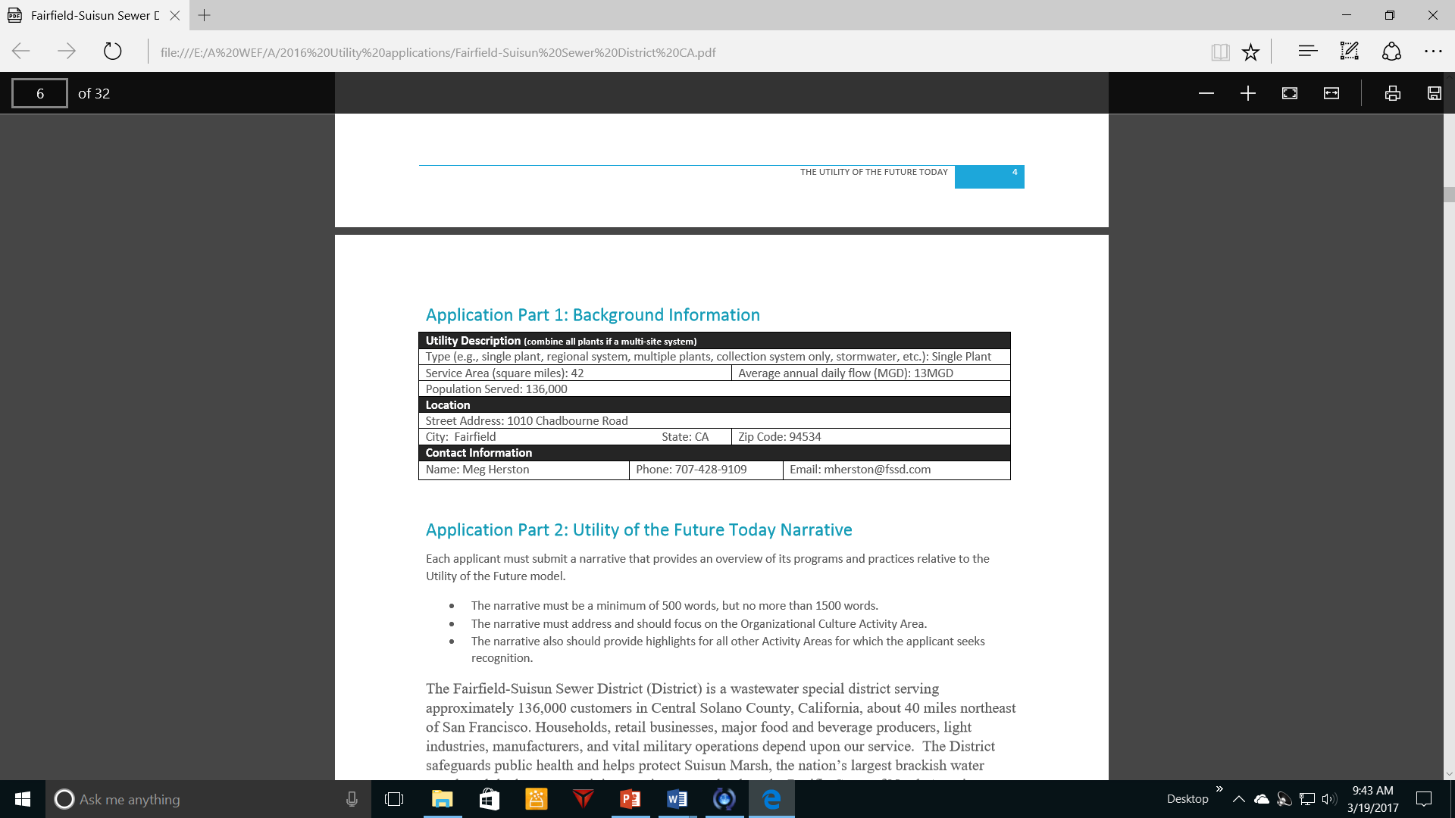

**ORGANIZATIONAL CULTURE NARRATIVE:**

The Fairfield-Suisun Sewer District (District) is a wastewater special district serving approximately 136,000 customers in Central Solano County, California, about 40 miles northeast of San Francisco. Households, retail businesses, major food and beverage producers, light industries, manufacturers, and vital military operations depend upon our service. The District safeguards public health and helps protect Suisun Marsh, the nation’s largest brackish water marsh and the largest remaining contiguous wetland on the Pacific Coast of North America. More details of the information in this application can be found on our website at http://www.fssd.com.

Over several decades, the District has evolved from a technical engineering entity to a valuable resource manager, a partner in local economic development, and an active member of the watershed community. The District has taken numerous actions to shift traditional thinking about the way wastewater utilities are run towards the Utility of the Future (UoTF) model— fostering collective responsibility, supportive partnerships, and shared problem solving. Organizational Culture At the heart of the District’s progress is an organizational culture that embraces positive change, empowering the workforce to imagine, create, test, and implement innovative approaches—from everyday work to extreme challenges. Following the 2008 transition from Contract Operations to Owner Operations, the District designed and implemented an organizational model that builds on the successes of its public sector service and maintains the efficiencies of private-sector operations to deliver high-performing, award-winning service with some of the lowest sewer service rates in the San Francisco Bay Area.

The District is a highly collaborative organization. By fostering a relatively flat organizational structure, minimizing bureaucracy, and promoting employee empowerment, the District achieves a high degree of cooperation and partnership between departments to seek out the best overall solutions to shared challenges. The District’s SuperGroup, a cross-departmental team consisting of both formal and informal leaders, holds monthly alignment meetings to ensure continuous improvement. When questioned at a recent SuperGroup meeting, helpfulness, responsibility, creativity, and flexibility were recurring themes listed as core descriptors of the District workforce. Employees in all departments are encouraged to find and fix inefficiencies.

The District was recognized for this culture by the California Water Environment Association, earning an Engineering Achievement Award in 2014 for its Suisun-Central Pump Station Forcemain Equalization project. This project was built upon a concept from a pump station mechanic. Rather than spend $18 million to expand an under-capacity pump station and forcemain, the District was able to optimize existing assets by inter-connecting two adjacent forcemains with lower-cost modifications to increase the capacity of the Suisun Pump Station.

As another example, the District has an informal but highly effective cross-training program, where Operations, Maintenance, and Engineering are encouraged to job shadow each other to improve job understanding and promote continuous improvement for the entire District. In addition to the benefits of job shadowing, two of the District’s five engineering project managers have become licensed wastewater treatment plant operators, creating a high performing team that is able to actively collaborate on cross-departmental issues. Staff has implemented numerous expense reduction measures, with the most significant through reduction of staff through work re-design and redistribution to existing staff when a position is vacated. Since 2008, 11 positions have been consolidated, saving about $1.1M per year while providing meaningful professional development and leadership opportunities to remaining staff.

The District also supports a highly effective safety program, resulting in no lost-time accidents for over 12 consecutive years and savings of approximately $40,000 in workers’ compensation premiums each year. Other Activity Areas In addition to Organizational Culture Activities, the District is engaged in several other UoTF Activity Areas, including beneficial biosolids use, community engagement, energy efficiency, energy recovery, water reuse, and watershed stewardship. Beneficial Biosolids Use In 2015, the District embarked on a unique public-private partnership with Lystek International, Inc., an organic materials recovery firm, to develop a new regional Fairfield Organic Materials Recovery Center (OMRC) at the District’s treatment plant site. Patterned after successful operations in Canada, the OMRC will be the first facility of its kind in the United States.

The OMRC will process all of the District’s annual 13,000 wet tons of Class B biosolids plus capacity for another 137,000 wet tons annually from agencies in the San Francisco Bay Area. The new OMRC is under construction with startup anticipated in summer 2016.

The OMRC will transform biosolids into multiple marketable products including a Class A nutrient-rich liquid fertilizer called LystaGro, a recycle product to enhance digestion called LystaMize, and a carbon supply product for Biological Nutrient Removal called LystaCarb.

In addition to providing long-term biosolids management and marketable products, the OMRC will reduce the impact of nutrients in the dewatering sidestream and ultimately eliminate the District need to dewater digested solids. The facility is also being developed to process other organics into marketable products that are currently being landfilled.

Community Engagement

The District partners with other agencies on classroom outreach in order to minimize duplication and provide the widest reach. Solano County Water Agency, Solano County Department of Resource Management, and the Fairfield-Suisun Sewer District fund the Solano Resource Conservation District’s Suisun Marsh Watershed & Wetland Education Program. This hands-on, field trip based program helps children learn the concept of a watershed and the impacts of humans on their watershed. The District is a member of the School Water Education Program (SWEP) partnership. SWEP’s educational programs are multi-disciplinary and aligned with content standards for California schools. The programs encourage students to develop a healthy attitude of personal responsibility towards the environment, and they help develop skills needed to contribute meaningfully to decision-making on issues involving the community’s natural resources.

The District encourages the public to consider the environment in their daily activities through a variety of reoccurring public service announcements on 95.3 KUIC’s regional Hometown Green radio campaign. Partnering with other agencies significantly reduces the cost of airing the segments and allows messages to reach as broad an audience as possible. The segments, which are written by and recorded on-air by staff, include messages regarding the connectedness of streets to local creeks, the importance of recycling, and reducing waste.

Energy Efficiency

Energy efficiency is a key driver for every decision made at the District. Treatment plant operators are provided with training on the dynamics of the treatment plant’s various power sources, and develop and implement procedures that maximize the use of renewable or off-peak utility power. This has resulted in modifications to the timing and duration of emergency generator testing, cogeneration engine preventative maintenance work, and filter backwashing. Major maintenance projects and new capital projects always consider energy efficiency and overall life-cycle cost rather than capital cost alone. This has resulted in the selection of premium-efficiency motors, LED lighting, and process equipment that operates more efficiently.

Energy Recovery

The District strives to obtain as much energy as possible from waste products and renewable energy. Over the past 5 years, the District has produced or acquired more than 67% of its power from 3 renewable sources – cogeneration, solar, and wind. The District’s two cogeneration engines combust digester gas (a potent greenhouse gas) to generate more than 40 percent of the annual energy need at the treatment plant. Waste heat is also used to heat the anaerobic digesters. Upon start-up of the OMRC at the plant, a small portion of the final product will be returned to the anaerobic digesters to increase gas production and increase the energy by approximately 25%.

The District has a power purchase agreement for a 1 MW solar farm on the District’s property, which generates over 20 percent of the plant’s electrical needs in a sustainable manner at a controlled cost. The District’s four wind turbines provide 2% of renewable power to the treatment plant.

Water Reuse

The District has been producing and distributing recycled water since 1974. Nearly 400 million gallons of treated wastewater is reused each year for crop irrigation and dust control. A majority of plant effluent is supplied to the Suisun Marsh to enhance water quality to sustain this critical part of the San Francisco Bay-Delta estuary ecosystem. The District has received numerous state and national awards for its commitment to innovation and excellence. From a state-of-the art treatment system, to engaging outreach programs, the District has proven the power of a highly qualified, environmentally responsible, and customer-focused team of public employees.

FSSD provides opportunities for employees in all departments to find & fix inefficiencies and we have adopted a continual improvement framework for both capital projects and standard procedures.

The District is committed to financial sustainability – we conduct long range financial planning and we are currently developing a comprehensive asset management plan.

The District fosters cross-functional team-oriented approaches. Highly successful cross departmental team efforts include asset management, permit compliance, contingency planning, and knowledge management.

Staff has implemented numerous expense reduction measures, with the most significant through reduction of staff through work redesign/redistribution when a position is vacated.

