2018 Application FAQs

The Utility of the Future Today
  - Joint Recognition Program

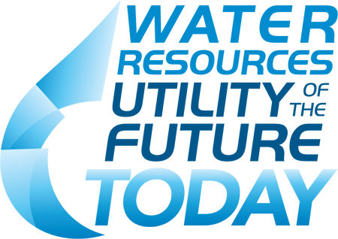

Q: Who is eligible to apply for the recognition program?
A: Public and private water sector utilities of all sizes that can demonstrate achievement of the application requirements are encouraged to apply. Wastewater treatment plants that treat stormwater are eligible to apply, but would not be assessed only on the basis of their stormwater operations.

Q: Is there a cost to apply for recognition?
A: No! The Recognition Program is free of cost to participants.

Q: When are the 2018 applications due, and where do I send the application?
A: Applications are due by 5:00pm Eastern Time, May 30, 2018 and should be sent to UtilityRecognition@wef.org.

Q: What if I have questions about eligibility or the application?
A: Please contact UtilityRecognition@wef.org.

Q: What format is required?
A: Applicants must fill out the application form in Microsoft Word and submit as a Word document. Attachments, graphics, charts, photos or additional materials will not be accepted as part of an application package.

Q: Can I include attachments with my application?
A: Attachments, graphics, charts, photos or additional materials will not be accepted as part of an application package.

Q: When will applicants be informed whether or not they were selected?
A: Applicants will be informed whether or not they were selected for recognition by or before July 13, 2018 by email or phone. A ceremony will be held at WEFTEC in New Orleans, Louisiana on September 29 - October 3, 2018 to celebrate recognition recipients. Applicants are not required to attend WEFTEC to receive recognition. Selected utilities will receive a Utility of the Future Today flag to proudly hang/fly as well as a certificate.

Q: What recognition will successful applicants receive?
A: The Program Partners will host a ceremony at WEFTEC in New Orleans, Louisiana on October 2, 2018 to celebrate recognition recipients. Applicants are not required to attend WEFTEC to receive recognition. Selected utilities will receive a Utility of the Future Today flag to proudly hang/fly as well as a certificate.

Q: If I have a multi-plant system, can I apply for only one plant?
A: No, recognition is acknowledged on a system-wide basis. However, if a multi-plant system has just one plant that is undertaking Utility of the Future practices that can still be a basis for receiving system-wide recognition.

Q: If my utility applied in 2016 and/or 2017 for more than one Activity Area and was successful; how will I know which Activity Areas were recognized?
A: The 2016 and 2017 Compendium of Honorees lists all Activity Areas that were recognized for each utility. http://www.wef.org/UtilityoftheFuture

Q: If my utility was successfully recognized, how long is that recognition valid?
A: Utility of the Future Today recognition is granted for a three-year period – this applies to both the Organizational Culture narrative and recognition, as well as the additional Activity Area(s). After three years, program members must renew their recognition. The applicant will need to: 1) show advancements in Organizational Culture, and 2) either show advancement in a previously recognized Activity Area or apply in a new Activity Area.

Q: If my system received recognition in 2016, can we reapply for recognition in additional areas the following year, or do we have to wait the full three years to apply again?
A: If you applied in 2016 and/or 2017 for an Activity Area and were not recognized for it, we encourage you to reapply in 2018. The existing (first year) Recognition Program members are grandfathered in under the new framework. Their 2016 recognition is valid for three years, as stated in the 2016 application package. In the subsequent two years after receiving recognition, program members are invited (but not required) to submit up to one additional Activity Area annually to receive further recognition during their three-year membership.
For example: a utility recognized in 2016 in Watershed Stewardship may apply for recognition in 2017 and 2018 for one additional activity area per year by submitting materials only for that activity area and omitting application information related to Organizational Culture (Application Part 2). In 2019, the utility may reapply to renew their recognition.

Q: How many utilities will be selected for recognition each year?
A: There is no set limit for the number of applicants that will be selected. It’s important to remember this is not a competition; but a recognition program. Reviewers will evaluate each application independently of all other applications.

Q: What are the qualifications of the review panel?
A: The review panel consists of six utility general managers/executives.

Q: The application states that utilities must have ‘no major violations’ to qualify for recognition. What constitutes a ‘major violation’?
A: Applicants must have no major permit violations in the past year prior to the submission date of their application, and must be in full compliance with NPDES permit for the preceding calendar year.
If applicants are concerned about what constitutes a major violation, they can reach out to state regulatory agencies as they may define ‘major’ violations somewhat differently.

