The Utility of the Future Today

Joint Recognition Program

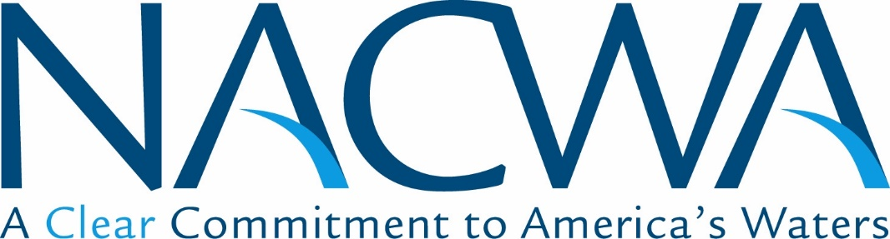WEF Logo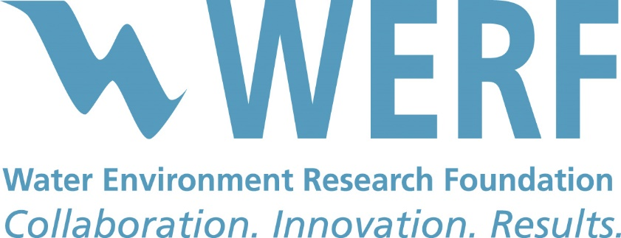

**2016 Final Application Package – *May 4, 2016***

*EPA is participating in an advisory capacity*

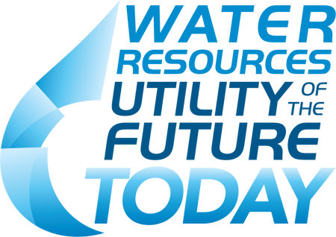

# APPLICATION FOR RECOGNITION

**The “Water Resources Utility of the Future”** was first articulated in a 2013 publication jointly prepared by the National Association of Clean Water Agencies (NACWA), the Water Environment Federation (WEF), and the Water Environment Research Foundation (WERF). *The Water Resources Utility of the Future: A Blueprint for Action* sought to capture in one place current, emergent, and possible wastewater utility opportunities that, packaged together, presented a revolutionary future for the sector. That revolution would transform the traditional wastewater treatment system to a community-based resource recovery center and leader in the overall sustainability and resilience of the communities they serve. This Recognition Program has been specifically designed to further promote and enable the emergence of this new business model for the sector and recognition for those achieving these achievements.

The sponsoring organizations for this recognition program understand that substantial excellence in the operations of wastewater treatment systems exists today. Many utilities optimize and continually improve their operations, consistently meet or exceed their regulatory requirements, plan and invest effectively for the maintenance, repair and replacement of their infrastructure, and engage their employees and communities in meaningful and productive ways. A variety of initiatives already exist to promote and acknowledge excellent performance and sustainable management of utilities focused on our sector’s historic focus – providing reliable, affordable, and responsible wastewater collection and treatment services. The most prominent of these is Effective Utility Management (EUM), which is supported by EPA and major water sector associations. EUM is based on *The Ten* ***Attributes of******Effectively Managed Utilities and Keys to Management Success*** *(*[*www.WaterEUM.org*](http://www.WaterEUM.org)*)*, and the awards programs and other resources that have been developed in support of it.

This ***Utility of the Future Recognition Program*** seeks to promote actions that build on this foundation of excellent management and help small, medium, and large utilities transform their operations over time. The Utility of the Future Activity Areas identified in this application package focus on the key building blocks to this transformation: recovery and new uses of a full range of resources; engagement as a leader in the full water cycle and broader social, economic, and environmental sustainability of the community. In addition, transformation of the internal utility culture in support of these innovations; and engagement in the community and formation of partnerships are necessary for success when operating outside of the traditional span of control of the utility.

# Program Statement of Purpose

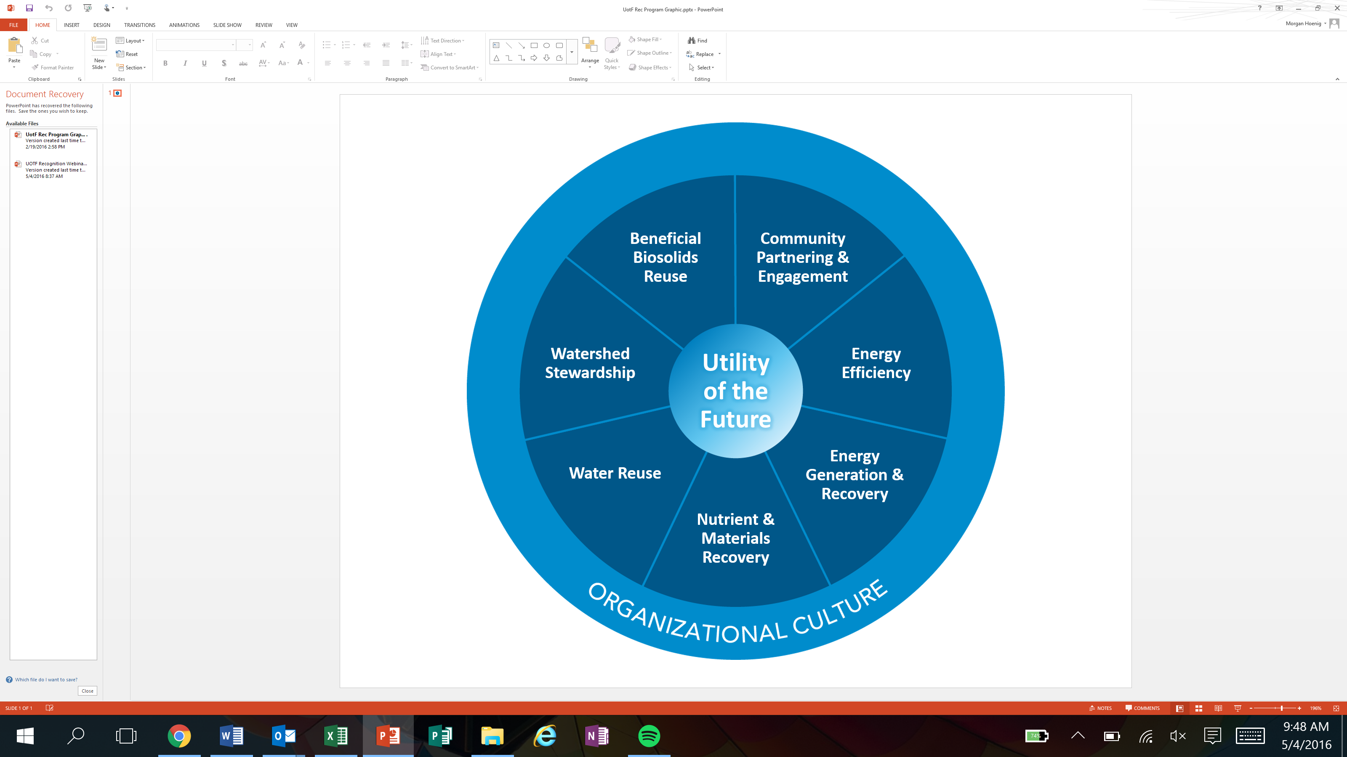The Utility of the Future Today Recognition Program seeks to reach deeply into the water sector to form and motivate a community of like-minded, self-identified water utilities engaged in advancing resource efficiency and recovery, developing proactive relationships with stakeholders, and establishing resilient, sustainable, and livable communities. The Recognition Program, through the aggregation and sharing of utility advancements and experiences, will enable participants across a broad continuum of capacities and capabilities to learn from each other and continually grow and sustain their efforts to be, and continually advance the concept of, the Utility of the Future.

The Recognition Program seeks to encourage utilities to embed the principles of the Utility of the Future within their organization, beginning with Organizational Culture. Organizational Culture is seen as the foundation by which all other Utility of the Future Activity Areas are sustainably supported.

Utilities receiving recognition through this program are asked to share their practices and experiences to create a community of practice around the Utility of the Future Today, and to enable other utilities to continually learn from each other and evolve as a sector.

# Eligible Applicants

* Public and private wastewater utilities of all sizes are encouraged to apply.
* Applicants must have no major permit violations in the past year prior to the submission date of their application.

# Application Requirements

Applicants must submit the following written materials to be considered for recognition. Each are described further in this information:

* **Application Part 1:** Background Information
* **Application Part 2:** *Utility of the Future Today* Narrative
* **Application Part 3:** 
  + Organizational Culture Activity Area response
  + Plus, response for at least one additional Activity Area (described below) of the applicant’s choice
* **Application Part 4:** Signed certification statement

Applicants should fill out the form in Microsoft Word and submit either as a Word or PDF document to [**UtilityRecognition@wef.org**](mailto:UtilityRecognition@wef.org) by **5:00pm Eastern Time, June 17, 2016**. No attachments, graphics, charts, photos or additional materials will be accepted as part of an application package.

# Basis for Recognition

Successful applicants will demonstrate that they are engaged in their selected Activity Areas in a meaningful and robust manner, consistent with the principles of the Utility of the Future. Reviewers will take into consideration an applicant’s current engagement and performance, as well as projected future results.

# Notification and Presentation of Recognition

Applicants will be informed whether or not they were selected for recognition by or before July 29, 2016 by email or phone. A ceremony will be held at WEFTEC in New Orleans, Louisiana on September 27, 2016 to celebrate recognition recipients. Applicants are not required to attend WEFTEC to receive recognition.

# Recognition Renewal Process

Once recognition is received, recognized utilities may reapply to be recognized again after three years.

To maintain recognition after the third year, the participant must re-apply and demonstrate continual improvement. This occurs by either showing performance advancements in their *previously recognized* Activity Areas and/or by adding one or more *new* Activity Areas to their application.

Sponsoring organizations reserve the right to withdraw recognition from any previously selected applicant at any time.

Application Contents

**Part 1: Background Information5**

**Part 2: Utility of the Future Today Narrative5**

**Part 3: Utility of the Future Today Activity Areas 5**

Activity Area 1: Organizational Culture 6

Activity Area 2: Beneficial Biosolids Reuse 8

Activity Area 3: Community Partnering & Engagement 10

Activity Area 4: Energy Efficiency 12

Activity Area 5: Energy Generation & Recovery 14

Activity Area 6: Nutrient & Materials Recovery 16

Activity Area 7: Water Reuse 17

Activity Area 8: Watershed Stewardship 19

**Application Part 4: Certification Statement 21**

**Appendix 1: Additional Example Activities 22**

**Appendix 2: Additional Example Performance Measures & Results 24**

# Application Part 1: Background Information

|  |  |  |  |
| --- | --- | --- | --- |
| **Utility Description (combine all plants if a multi-site system)** | | | |
| Type (e.g., single plant, regional system, multiple plants, collection system only, stormwater, etc.): | | | |
| Service Area (square miles): | | Average annual daily flow (MGD): | |
| Population Served: | | | |
| **Location** | | | |
| Street Address: | | | |
| City: State: | | Zip Code: | |
| **Contact Information** | | | |
| Name: | Phone: | | Email: |

# Application Part 2: Utility of the Future Today Narrative

Each applicant must submit a narrative that provides an overview of its programs and practices relative to the Utility of the Future model.

* The narrative must be a minimum of 500 words, but no more than 1500 words.
* The narrative must address and should focus on the Organizational Culture Activity Area.
* The narrative also should provide highlights for all other Activity Areas for which the applicant seeks recognition.

# Application Part 3: Utility of the Future Today Activity Areas

**Requirements**

Each applicant is required to submit responses for the **Organizational Culture** Activity Area, and at least one additional Activity Area of their choosing.

Applicants may submit responses for as many Activity Areas as they choose beyond the minimum requirement. There is no “penalty” for submitting responses for only two Activity Areas – each activity area will be assessed independently of all others.

**Instructions**

For each Activity Area that an applicant chooses to submit responses, applicants are asked to demonstrate robust engagement in that Activity Area.

Activities:Example activities are provided to which applicants will indicate “yes” or “no” for whether or not they are engaged in these example activities. Additional space is provided for applicants to list additional or alternative activities which they are engaged in relative to the Activity Area, and which they believe demonstrate or further demonstrate robust engagement in the Activity Area.

Performance Measures & Results: For each Activity Area for which responses are submitted, applicants are asked to list the performance measures which they use to track results in the Activity Area, and to describe their results (quantitative when possible/appropriate) – results can be actual results realized over the past 12 months, or anticipated results for the future as a result of new programs or practices. Example performance measures are provided for each area.

## Activity Area 1: Organizational Culture

*Organizational culture relates to the intentional establishment of organizational excellence that inspires and embraces positive change and empowers the workforce to imagine, create, test, and implement innovative approaches from every day work to extreme challenges. It enforces a culture of managing and recovering valuable resources, rather than one of the disposal of “waste.” It promotes leadership that establishes a long-term vision for the organization, embodies a commitment to cultivating the organization’s culture, and embodies communication that creates employee understanding, makes knowledge more productive, and harnesses the power of employee engagement.*

**Example Activities:**

Please check yes or no for each of the example activities described below for this Activity Area.

|  |  |  |
| --- | --- | --- |
|  | **Activities completed or underway?** | |
| **Activity Description** | **Yes** | **No** |
| Proactive leadership that engages in both internal organizational and broader external community priorities |  |  |
| Establishes a participatory, collaborative organization dedicated to continual learning, improvement, and innovation |  |  |
| Workforce and leadership development program in place to assure recruitment, retention, and competency of utility staff relative to a Utility of the Future business model. Development program includes a leadership and management skills training program that provides both formal and informal leadership opportunities for employees |  |  |
| Employee “in-reach” program established to share work experiences and ensure greater understanding of the utility’s key strategy relative to the Utility of the Future business model |  |  |
| Innovation initiatives adopted that encourage risk-taking, and that are adequately funded and staffed |  |  |

**Additional Activities:**

If your utility is engaged in additional or alternative activities (either completed or underway) that you believe demonstrate a robust engagement with this Activity Area in the context of the Utility of the Future Today, please describe them below (no more than three sentences per activity).

|  |
| --- |
| **Additional Activity Descriptions (OPTIONAL)** |
|  |
|  |
|  |
|  |
|  |

*REFER TO* ***APPENDIX 1*** *FOR OTHER ADDITIONAL EXAMPLE ACTIVITIES.*

**Performance Measures & Results:**

Using the table provided, list your key performance measures for this Activity Area, and provide the results that you have achieved relative to each measure. Example performance measures are listed below.

*Example Performance Measures*

* *Number of sessions, number of people and type of workforce development activities conducted (e.g., trainings)*
* *Level of employee engagement in the goals and vision of the Utility of the Future business model*
* *Number of open positions that internal candidates can qualify for, as a result of employee training and enrichment programs*
* *Resource efficiency improvements related to staff utilization*

|  |  |
| --- | --- |
| **Your Performance Measure(s)** | **Your Results (quantitative or qualitative)** |
|  |  |
|  |  |
|  |  |
|  |  |
|  |  |

*REFER TO* ***APPENDIX 2*** *FOR OTHER ADDITIONAL EXAMPLE PERFORMANCE MEASURES & RESULTS.*

## Activity Area 2: Beneficial Biosolids use

*Wastewater-produced biosolids can be beneficially used to support: agriculture, silviculture, horticulture, fire restoration, and general landscape maintenance through land application; production of marketable products such as compost, amended topsoil, or construction products (e.g., bricks, road bed); and land reclamation as a substitute for other fill materials. This Activity Area does not include use of biosolids to produce energy or recovery of resources from biosolids.*

**Example Activities:**

Please check yes or no for each of the example activities described below for this Activity Area.

|  |  |  |
| --- | --- | --- |
|  | **Activities completed or underway?** | |
| **Activity Description** | **Yes** | **No** |
| Board/executive management policy created, advocating beneficial biosolids use |  |  |
| Business case evaluation conducted for beneficial biosolids use program |  |  |
| Marketing plan for products created |  |  |
| Participation in or certification in National Biosolids Partnership or ISO programs |  |  |
| Public involvement and education activities related to public acceptance and support of beneficial biosolids use |  |  |

**Additional Activities:**

If your utility is engaged in additional or alternative activities (either completed or underway) that you believe demonstrate a robust engagement with this Activity Area in the context of the Utility of the Future Today, please describe them below (no more than three sentences per activity).

|  |
| --- |
| **Additional Activity Descriptions (OPTIONAL)** |
|  |
|  |
|  |
|  |
|  |

*REFER TO* ***APPENDIX 1*** *FOR OTHER ADDITIONAL EXAMPLE ACTIVITIES.*

**Performance Measures & Results:**

Using the table provided, list your key performance measures for this Activity Area, and provide the results that you have achieved relative to each measure. Example performance measures are listed below.

*Example Performance Measures:*

* *Percent of biosolids beneficially used vs. total volume produced on an annual basis*
* *Quantification of natural resources conserved through substitution (e.g., pounds of phosphorous or other fertilizers substituted for by biosolids)*
* *Demonstrated performance against projected performance in business case (e.g., actual versus projected biosolids volume acquired for soil amendment by agricultural producers)*
* *Tons of carbon sequestered in the soil via land application of Class A and/or Class B biosolids*

|  |  |
| --- | --- |
| **Your Performance Measure(s)** | **Your Results (quantitative or qualitative)** |
|  |  |
|  |  |
|  |  |
|  |  |
|  |  |

*REFER TO* ***APPENDIX 2*** *FOR OTHER ADDITIONAL EXAMPLE PERFORMANCE MEASURES & RESULTS.*

## Activity Area 3: Community Partnering & Engagement

*Community partnering is collaboration with local organizations and other stakeholders to enable the utility to meet its own Utility of the Future goals while also enhancing the overall environmental, economic, and social wellbeing of the community or communities it serves. Community engagement is the interaction with customers and other local stakeholders to provide ongoing opportunities for dialog along with communication and education related to utility operations and the value of water and utility services. Under Community Partnering & Engagement, the utility proactively engages with stakeholders and community decision makers to promote the utility as a valued, competent, and trustworthy community asset.*

**Example Activities:**

Please check yes or no for each of the example activities described below for this Activity Area.

|  |  |  |
| --- | --- | --- |
|  | **Activities completed or underway?** | |
| **Activity Description** | **Yes** | **No** |
| Partnerships in place with one or more community organizations, with specific name given to partnership and objectives for the partnership established (e.g., a formalized partnership among community transportation, parks, and land use organizations for the incorporation of green infrastructure to reduce flooding and overflows) |  |  |
| Participation in projects with neighborhood groups/stakeholders to create recreational opportunities and community assets (e.g., parks, enhanced public space) |  |  |
| Use of a Triple Bottom Line approach, including engagement with stakeholders, to analyze growth planning alternatives, considering financial, social, and environmental costs and benefits |  |  |
| Participation in regular meetings with community stakeholders and offering of environmental education opportunities (e.g., river walks) |  |  |
| Web presence established with social media engagement |  |  |

**Additional Activities:**

If your utility is engaged in additional or alternative activities (either completed or underway) that you believe demonstrate a robust engagement with this Activity Area in the context of the Utility of the Future Today, please describe them below (no more than three sentences per activity).

|  |
| --- |
| **Additional Activity Descriptions (OPTIONAL)** |
|  |
|  |
|  |
|  |
|  |

*REFER TO* ***APPENDIX 1*** *FOR OTHER ADDITIONAL EXAMPLE ACTIVITIES.*

**Performance Measures & Results:**

Using the table provided, list your key performance measures for this Activity Area, and provide the results that you have achieved relative to each measure. Example performance measures are listed below.

*Example Performance Measures:*

* *Number and type of specific projects completed (e.g., rain gardens installed, innovative technologies, or other innovative practices adopted) associated with a partnership*
* *Number and type of formal recognitions of partnerships by outside groups (e.g., state or national award) and any associated results for the community (e.g., acres of green space added in the community)*
* *Performance improvements resulting from a partnership (e.g., reduced volume of flooding or reduced greenhouse gas emissions)*
* *Number of ongoing communications network actions/activities (e.g., website hits, newsletters, social media activity)*
* *Type and number of working agreements and collaborative initiatives for growth planning between and across different levels of government*

|  |  |
| --- | --- |
| **Your Performance Measure(s)** | **Your Results (quantitative or qualitative)** |
|  |  |
|  |  |
|  |  |
|  |  |
|  |  |

*REFER TO* ***APPENDIX 2*** *FOR OTHER ADDITIONAL EXAMPLE PERFORMANCE MEASURES & RESULTS.*

## Activity Area 4: Energy Efficiency

*Energy efficiency is the reduction of overall energy use by the utility. A utility is more energy efficient if it delivers more services for the same amount of energy or the same services for less energy.*

**Example Activities:**

Please check yes or no for each of the example activities described below for this activity area.

|  |  |  |
| --- | --- | --- |
|  | **Activities completed or underway?** | |
| **Activity Description** | **Yes** | **No** |
| Indication of management commitment (e.g., energy efficiency standard operating procedures; board/executive management energy efficiency policy, including quantitative goals developed and shared with stakeholders) |  |  |
| Energy audit/benchmarking conducted to identify priorities for energy efficiency improvements |  |  |
| ‘Energy teams’ established and individuals empowered within the utility for energy efficiency activities (e.g., an “energy advocate” or “energy champion”) |  |  |
| Energy management-related training provided to plant staff |  |  |
| Utilization of energy conserving operational methods (e.g., optimization of primary sedimentation to reduce utilization of pure oxygen) |  |  |

**Additional Activities:**

If your utility is engaged in additional or alternative activities (either completed or underway) that you believe demonstrate a robust engagement with this Activity Area in the context of the Utility of the Future Today, please describe them below (no more than three sentences per activity).

|  |
| --- |
| **Additional Activity Descriptions (OPTIONAL)** |
|  |
|  |
|  |
|  |
|  |

*REFER TO* ***APPENDIX 1*** *FOR OTHER ADDITIONAL EXAMPLE ACTIVITIES.*

**Performance Measures & Results:**

Using the table provided, list your key performance measures for this Activity Area, and provide the results that you have achieved relative to each measure. Example performance measures are listed below.

*Example Performance Measures:*

* *KWh reductions in site energy use/intensity – to date or anticipated in the future (e.g., change in energy required per million gallons treated, or change in energy required per hour of pump operation)*
* *Translation of energy use/intensity reductions to greenhouse gas emission reductions – to date and anticipated in the future*
* *Current and anticipated investment (in USD) in energy efficiency projects or activities, and anticipated savings (in USD)*
* *USD value of other re-investments made as a result of the savings from reduced energy costs*

|  |  |
| --- | --- |
| **Your Performance Measure(s)** | **Your Results (quantitative or qualitative)** |
|  |  |
|  |  |
|  |  |
|  |  |
|  |  |

*REFER TO* ***APPENDIX 2*** *FOR OTHER ADDITIONAL EXAMPLE PERFORMANCE MEASURES & RESULTS.*

## Activity Area 5: Energy Generation & Recovery

*Energy generation and recovery captures efforts to minimize the use of non-renewable energy; generate renewable (green) energy to the maximum extent practicable; and recover thermal, chemical, and hydraulic energy to the maximum extent possible. In doing so, the clean water Utility of the Future Today will not only seek to optimize its water quality performance, but also look to minimize its carbon footprint, reduce its vulnerability to climate change, and better manage energy costs and requirements.*

**Example Activities:**

Please check yes or no for each of the example activity activities described below for this Activity Area.

|  |  |  |
| --- | --- | --- |
|  | **Activities completed or underway?** | |
| **Activity Description** | **Yes** | **No** |
| Indication of management commitment (e.g., standard operating procedures; board/executive management renewable energy conversion policy, including quantitative goals developed and shared with stakeholders) |  |  |
| Internal energy sources evaluated (e.g., biogas, hydropower, heat in wastewater), and/or renewable energy sources evaluated on an ongoing basis (e.g., solar, wind, co-digestion) |  |  |
| Recovery of digester gas in a combined heat and power (CHP) system, and boilers in place (for process and building heating) |  |  |
| Conversion of digester biogas to electricity and heat, and/or transportation fuel |  |  |
| Solar panels, wind turbines, heat recovery, in conduit hydro, and/or hydroelectric power generation systems installed |  |  |

**Additional Activities:**

If your utility is engaged in additional or alternative activities (either completed or underway) that you believe demonstrate a robust engagement with this Activity Area in the context of the Utility of the Future Today, please describe them below (no more than three sentences per activity).

|  |
| --- |
| **Additional Activity Descriptions (OPTIONAL)** |
|  |
|  |
|  |
|  |
|  |

*REFER TO* ***APPENDIX 1*** *FOR OTHER ADDITIONAL EXAMPLE ACTIVITIES.*

**Performance Measures & Results:**

Using the table provided, list your key performance measures for this Activity Area, and provide the results that you have achieved relative to each measure. Example performance measures are listed below.

*Example Performance Measures:*

* *Reduced non-renewable energy use and carbon footprint (e.g., percent of non-renewable energy use reduction, percent of greenhouse gas emissions reduction)*
* *Reduced reliance on the power grid (e.g., percent reduction of energy utilization coming from the grid), and corresponding reduced vulnerability to climate change and energy price fluctuations*
* *Cost savings (e.g., return on investment proceeds and/or avoided energy costs)*
* *Percent increase in renewable energy production (e.g., solar generation) or utilization (e.g., purchase of renewable energy through the grid)*

|  |  |
| --- | --- |
| **Your Performance Measure(s)** | **Your Results (quantitative or qualitative)** |
|  |  |
|  |  |
|  |  |
|  |  |
|  |  |

*REFER TO* ***APPENDIX 2*** *FOR OTHER ADDITIONAL EXAMPLE PERFORMANCE MEASURES & RESULTS.*

ACTIVITY AREA 6: NUTRIENT & MATERIALS RECOVERY

*Nutrient & Materials Recovery is the extraction of ammonium (NH4), phosphorus compounds, nitrogen compounds, metals, and other marketable commodities during the wastewater treatment process, or lower tech activities such as recycling paper, pallets, containers, scrapped hardware segregated for recycling.*

**Example Activities:**

Please check yes or no for each of the example activity activities described below for this Activity Area.

|  |  |  |
| --- | --- | --- |
|  | **Activities completed or underway?** | |
| **Activity Description** | **Yes** | **No** |
| Materials recovery strategy established and communicated with utility employees |  |  |
| Adequate staffing to support materials recovery program (contractual or in-house) |  |  |
| Market assessment conducted for recovered materials |  |  |
| Contracts or agreements in place for materials provision |  |  |
| Ongoing exploration and evaluation of materials recovery opportunities |  |  |

*REFER TO* ***APPENDIX 1*** *FOR OTHER ADDITIONAL EXAMPLE ACTIVITIES.*

**Additional Activities:**

If your utility is engaged in additional or alternative activities (either completed or underway) that you believe demonstrate a robust engagement with this Activity Area in the context of the Utility of the Future Today, please describe them below (no more than three sentences per activity).

|  |
| --- |
| **Additional Activity Descriptions (OPTIONAL)** |
|  |
|  |
|  |
|  |
|  |

**Performance Measures & Results:**

Using the table provided, list your key performance measures for this Activity Area, and provide the results that you have achieved relative to each measure. Example performance measures are listed below.

*Example Performance Measures:*

* *Type and percent of materials recovered vs. materials available*
* *Revenue generated and/or costs avoided from materials recovery and marketing activities*
* *Demonstrated performance as projected in market assessment*
* *Private-public partnership for recovered material sales*

|  |  |
| --- | --- |
| **Your Performance Measure(s)** | **Your Results (quantitative or qualitative)** |
|  |  |
|  |  |
|  |  |
|  |  |
|  |  |

*REFER TO* ***APPENDIX 2*** *FOR OTHER ADDITIONAL EXAMPLE PERFORMANCE MEASURES & RESULTS.*

## Activity Area 7: Water Reuse

*Water reuse covers opportunities to reuse treated waters fit for beneficial purposes such as irrigation, buffering salt water intrusion, industrial processes, toilet flushing, fire protection, surface/groundwater augmentation, and ultimately human consumption.*

**Example Activities:**

Please check yes or no for each of the example activity activities described below for this Activity Area.

|  |  |  |
| --- | --- | --- |
|  | **Activities completed or underway?** | |
| **Activity Description** | **Yes** | **No** |
| Board/executive management reuse strategy established |  |  |
| Communications and outreach plan developed and implemented |  |  |
| Ongoing market assessment of reused water to public/private and public/public entities |  |  |
| Investments in reuse infrastructure |  |  |
| Building code changes to enable reuse (e.g., reuse water code) |  |  |

**Additional Activities:**

If your utility is engaged in additional or alternative activities (either completed or underway) that you believe demonstrate a robust engagement with this Activity Area in the context of the Utility of the Future Today, please describe them below (no more than three sentences per activity).

|  |
| --- |
| **Additional Activity Descriptions (OPTIONAL)** |
|  |
|  |
|  |
|  |
|  |

*REFER TO* ***APPENDIX 1*** *FOR OTHER ADDITIONAL EXAMPLE ACTIVITIES.*

**Performance Measures & Results:**

Using the table provided, list your key performance measures for this Activity Area, and provide the results that you have achieved relative to each measure. Example performance measures are listed below.

*Example Performance Measures:*

* *Water beneficially reused*
  + *Percent change of static water levels or reservoir due to new actions (augmentation)*
  + *Ratio of reuse quantity vs. wastewater volume processed (normalized change)*
* *Environmental benefits*
  + *Amount of movement or reduction of saltwater front (in feet)*
  + *Amount of decreased diversion of freshwater from sensitive ecosystems*
  + *Area irrigated solely by recycle water*
* *Local supply*
  + *Reduced dependence on purchased water and energy used to treat purchased water*
  + *Climate-independent water supply of reuse water*
* *Enhanced utility and community resiliency to water supply and climate variability*

|  |  |
| --- | --- |
| **Your Performance Measure(s)** | **Your Results (quantitative or qualitative)** |
|  |  |
|  |  |
|  |  |
|  |  |
|  |  |

*REFER TO* ***APPENDIX 2*** *FOR OTHER ADDITIONAL EXAMPLE PERFORMANCE MEASURES & RESULTS.*

## Activity Area 8: Watershed Stewardship

*Watersheds are the geographic areas that channel drainage into a river or stream system. They are defined by topographic boundaries and—depending on where they are located—might encompass complex natural ecosystems, highly urbanized landscapes, or elements of both. Watershed stewardship refers to utility investments and actions to improve water flow (reduced flooding/increased local capture) and quality conditions outside of the traditional utility span of infrastructure operations and control. It also draws on integrated growth planning to integrate wastewater infrastructure expansion, repair, and replacement planning with community development planning (i.e., area plans), stormwater management planning (i.e., TMDL implementation plans), climate resiliency planning, and economic development planning to maximize the benefits and fully assess cost implications (i.e., triple bottom line feasibility analyses). Activities can include urban Green Stormwater Infrastructure investments, conservation easements to preserve the ecosystem functions of undeveloped lands, and stream channel restoration.*

**Example Activities:**

Please check yes or no for each of the example activity activities described below for this Activity Area.

|  |  |  |
| --- | --- | --- |
|  | **Activities completed or underway?** | |
| **Activity Description** | **Yes** | **No** |
| Unified vision statement established that integrates water supply, water conservation, water recycling, runoff management, wastewater facilities planning, and infrastructure planning using a regional watershed approach |  |  |
| Green infrastructure deployment to enhance infiltration, evapotranspiration, treatment, or capture and reuse of stormwater |  |  |
| Watershed permitting strategy for multiple facilities (e.g., active nutrient water quality trading under a watershed-based permit) |  |  |
| Ecosystem enhancements for improved hydraulics or water quality, including:   * Riparian reforestation to enhance pollution mitigation functions * Stream channel restoration for increased hydrologic stability * Critical land acquisitions (e.g., conservation easements, buffer-zone purchases) |  |  |
| Climate impact resilience principles incorporated into planning for new, repair, and replacement of infrastructure |  |  |

**Additional Activities:**

If your utility is engaged in additional or alternative activities (either completed or underway) that you believe demonstrate a robust engagement with this Activity Area in the context of the Utility of the Future Today, please describe them below (no more than three sentences per activity).

|  |
| --- |
| **Additional Activity Descriptions (OPTIONAL)** |
|  |
|  |
|  |
|  |
|  |

*REFER TO* ***APPENDIX 1*** *FOR OTHER ADDITIONAL EXAMPLE ACTIVITIES.*

**Performance Measures & Results:**

Using the table provided, list your key performance measures for this Activity Area, and provide the results that you have achieved relative to each measure. Example performance measures are listed below.

*Example Performance Measures:*

* *Reduction in wet weather impacts (e.g., flooding, CSOs, SSOs, gallons of infiltrated water not reaching collection systems)*
* *Reduced unit costs for water quality improvements (e.g., financial benefits of a water quality trade)*
* *Enhanced pollution mitigation (e.g., sediment capture through green stormwater infrastructure)*
* *Increased hydrologic stability (e.g., reduction in flood-prone land area)*
* *Reductions (e.g., VSAT Risk Reduction Units change) in vulnerability to climate change*
* *Creation or enhancements to wetland areas for natural treatment/storage*

|  |  |
| --- | --- |
| **Your Performance Measure(s)** | **Your Results (quantitative or qualitative)** |
|  |  |
|  |  |
|  |  |
|  |  |
|  |  |

*REFER TO* ***APPENDIX 2*** *FOR OTHER ADDITIONAL EXAMPLE PERFORMANCE MEASURES & RESULTS.*

# Application Part 4: Certification Statement

*I, _____________________________________* [PRINT NAME]*, an approved representative of my organization, ___________________________________________* [ORGANIZATION NAME], *certify that all data and information provided in this application package is accurate to the best of my organization’s knowledge and has not been falsified. I certify that my organization is in good standing and has had no major permit violations in the 12 months prior to the date of submission of this application package.*

*_____________________________________* [SIGNATURE]

_________________________ [DATE]

# Appendix 1: Additional Example Activities

### Activity Area 1: Organizational Culture

* Establishes an integrated and well-coordinated senior leadership team
* Provides opportunities to consult with employees in new processes, innovations and designs before building
* Provides opportunities for employees to find and fix inefficiencies, share ideas for solutions to problems
* Drives an awareness and commitment to workplace safety
* Maintains attention to employee morale including opportunities to celebrate victories for the utility
* Established periodic tracking of progress toward meeting goals and milestones
* Participates in a mentoring program with other utilities to promote Utility of the Future practices
* EUM-based continuous improvement program in place
* Financial sustainability which could take the form of asset management; long range financial planning and policies or developing new business models to diversify income or leverage other investors.

### Activity Area 2: Beneficial Biosolids Reuse

* Ongoing exploration and evaluation of alternative uses for biosolids
* Risk management strategies in place to address threats to sustainability of practice
* Adequate staffing (internally or by contract) to support programs
* Environmental management systems in place
* Procedures to reduce generation of biosolids in treatment systems

### Activity Area 3: Community Partnering & Engagement

* Outreach conducted with other stakeholders and other community groups (e.g., regulators, local officials, watershed groups)
* Community workforce development programs in place
* Actively promotes community awareness of the value of water and wastewater and stormwater collection and treatment’s role in the social, economic, public, and environmental health of the community
* Involves stakeholders in the decisions that will affect them, understands what it takes to operate as a “good neighbor,” and positions the utility as a critical asset to the community

### Activity Area 4: Energy Efficiency

* Employee performance plans established that include energy program-related activities to support the utility’s energy vision and goals
* Energy efficiency master plan and communications strategy as part of utility’s overall strategic plan
* Energy efficiency team established and empowered to implement master plan and communicate results to management and staff
* Internal incentives in place for achieving energy efficiency goals
* Energy efficiency evaluated for all equipment purchases and capital projects
* Energy performance contracts or other similar mechanisms in place evaluated and in place, where appropriate
* Conduct and or participation in research activities
* Sub-metering conducted for critical process units
* Participation in voluntary energy efficiency programs (e.g., Energy Star)
* Utilization of energy conserving equipment wherever possible (e.g., utilization of peak shaving equipment to reduce usage)

### Activity Area 5: Energy Generation & Recovery

* Co-generation systems
* FOG receiving stations
* Heat recovery systems
* Mandate sustainable design practices
* Co-digestion systems
* Utility board/city council/board of supervisors have an energy and/or sustainability committee in place

### Activity Area 6: Nutrient & Materials Recovery

* Recovery of alkalinity in nitrogen removal processes
* Recovery of phosphorus for beneficial reuse
* Reduction in chemical use due to improved biological uptake
* Enhanced production of methane gas
* Improved use of methane gas for vehicle fuel, supplement to grid, other uses
* Implementing private company involvement in new technology for nutrient recovery/sale
* Revenue generated from sales of nutrients and/or other recoverable materials

Activity Area 7: Water Reuse

* Reuse for on-site irrigation, process water (vacuum pumps, seal waters, cooling towers, etc).
* Reuse off-site for industry, power generation/cooling, golf course irrigation and other uses
* Development of programs to reduce risk of reuse and improve guaranteed reuse water quality
* Injection of reuse water for salt water/groundwater control
* Indirect potable reuse (IPR) for downstream water supplies
* Steps in communicating to the public the realities of IPR and/or direct potable reuse (DPR)
* Internal plant methods to insure treated water quality fit-for-purpose reuse
* Use of in-house or external laboratories for testing water quality parameters

### Activity Area 8: Watershed Stewardship

* Holistic, integrated protection approach to manage significant potential sources of contaminants in the watershed that improves surface water quality and avoids transferring pollutants from one resource to another
* Integrated program to address wet weather issues, including such sources as regulated stormwater, unregulated runoff (nonpoint sources), CSOs, SSOs, peak flow at POTWs, and source water protection
* Systems that add value to the urban landscape with resilient, adaptable, affordable and environmentally sensitive water infrastructure that continues to provide basic services, but also enhanced recreational, aesthetic and environmental value
* Building code modifications that allow green infrastructure as acceptable options
* Maintenance policies that enable green infrastructure maintenance
* Workforce capable of evaluating and maintaining effective green infrastructure
* Built environment that supplements the function of the natural environment
* Evaluation of water quality trading options
* Integration of wastewater services with urban planning entities
* Financial methods that recognize the true cost of wastewater services and price it accordingly
* Feasibility study to assess policies that fully account for the benefits and costs of green infrastructure
* Participate in voluntary programs such as the Alliance for Water Stewardship
* Strong public-private partnerships, including investors who can benefit
* Closed loop systems that enhance nutrient and energy recovery
* Stakeholders comment on evaluation of alternatives in triple bottom line analysis, as appropriate

# Appendix 2: Additional Example Performance Measures & Results

Activity Area 1: Organizational Culture

* Examples where employees and stakeholders have made the necessary modifications within their control and capabilities
* Examples where infrastructure and/or overhead have the potential to be repaid with greater returns resulting from engaged employees, satisfied customers, and efficient operations

Activity Area 2: Beneficial Biosolids Use

* Impact on customer rates
* Increase in agricultural land application
* Increase in silviculture land application
* Increase in agricultural or silviculture growth yields
* Increase in improved soil characteristics resulting from biosolids amended soils
* Metrics for biosolids use for landscaping for green infrastructure projects
* Metrics for biosolids use for recreational fields, golf courses, and domestic use

### Activity Area 3: Community Partnering & Engagement

* Type and number of changes in operating practices of other partners (e.g., NPS controls by Ag. Producers, food producers, consumers)
* Level of community support for the benefits and costs of becoming a utility of the future today (e.g., annual survey results regarding community support for utility priorities)
* Support from and amount of contracting with local businesses
* Level of stakeholder involvement in decisions that affect them
* Number of outreach events conducted to publicize and build support for water and water services
* Type and number of collaborations on data collection and assessment
* Amount and effectiveness of public outreach as an integral part of project planning

### Activity Area 4: Energy Efficiency

* Percent of annual budget allocated to implementing priority energy efficiency improvements identified in energy audit
* Conduct and or participation in research activities
* Sub-metering conducted for critical process units
* Participation in voluntary energy efficiency programs (e.g., Energy Star)
* Utilization of energy conserving equipment wherever possible (e.g., utilization of peak shaving equipment to reduce usage)

### Activity Area 5: Energy Generation & Recovery

* Aesthetic/community benefits from green infrastructure
* Sequestering quantifiable amounts of carbon
* Amount of transmission losses eliminated when providing outside power to the facilities
* Change in the resilience of critical infrastructure
* Increase in use of renewable energy sources
* Renewable Energy Credit generation
* Percent of energy use that is renewable
* Percent of total plant power demand that is generated on-site from renewable sources

### Activity Area 6: Nutrient & Materials Recovery

* Enhancing sales by advertising for nutrients recovered
* Ability to store nutrients and materials to anticipate market value
* Third party investments in capital and operating/maintenance of nutrient recovery equipment
* Established goals of nutrient recovery based on total available, costs, value, etc.
* Internal tracking of non-recovered resources for further enhancements of recovery

Activity Area 7: Water Reuse

* Tracking costs for sales of treated water fit-for-purpose reuse
* Public acceptance of reuse commitments for non-potable opportunities
* Use of advanced treatment (ultrafilters (UF), reverse osmosis (RO), granular activated carbon (GAC)
* Type and use of enhanced disinfection of reuse water besides chlorine residual, such as UV light

### Activity Area 8: Watershed Stewardship

* Type and number of standardized approaches across regions and tools to support regional solutions
* Created or enhanced wetlands and riparian habitats (e.g., number of projects, or acres covered)
* Results of planning and projects between transportation and other public utilities for ratepayer savings
* Results of aligning operations across private and other utility and efficiencies gained in labor costs
* Implementation of a performance monitoring process

The Utility of the Future Today

Joint Recognition Program